

Web Programming



USER MANUAL

BY SAN SHWE

British University College

Table of Contents

**1.** **Introduction** 2

**1.1.** **Overview** 3

**2.** **Getting Started** 5

**2.1.** **Cautions and Warnings** 9

**2.2.** **Set-up Considerations** 10

**2.3.** **User Access Considerations** 11

**2.4.** **Accessing the System** 13

**2.5.** **System Organization and Navigation** 14

**2.5.1.** **System Organization** 14

**2.5.2.** **Navigation** 15

**2.5.2.1.** **Navigation Bars** 15

**2.5.2.2.** **Footer** 17

**2.5.2.3.** **Search Box** 17

**2.5.2.4.** **Find a Course** 18

**2.6.** **Exiting the System** 18

**3.** **Using the System** 19

**3.1.** **Home** 19

**3.2.** **International** 21

**3.3.** **Alumni** 22

**3.4.** **News** 24

**3.5.** **Admission** 24

**3.6.** **Contact Us** 25

**3.7.** **Study** 26

**3.7.1.** **Business** 29

**3.7.2.** **Engineering** 30

**3.7.3.** **Health** 31

**3.7.4.** **Information Technology** 32

**3.7.5.** **Security, Intelligence and Criminology** 33

**3.7.6.** **Information for Students** 34

**3.7.7.** **Entry Requirements** 34

**3.7.8.** **Fees and costs** 35

**3.7.9.** **Find a Course** 36

**3.7.10.** **Courses** 36

**3.8.** **Current Students** 38

**3.8.1.** **Scholarships** 39

**3.9.** **Gallery** 40

**3.10.** **About Us** 41

**3.10.1.** **Faculties** 41

**3.10.1.1.** **Faculty of Business** 42

**3.10.1.2.** **Faculty of Health** 43

**3.10.1.3.** **Faculty of Science and Engineering** 43

**3.11.** **Staff Portal** 44

**3.12.** **Student Portal** 51

**4.** **Troubleshooting & Support** 56

**References** 57

# **Introduction**

We are appreciative that you have selected the University of Sam (UOS) website as your entry point to a multitude of scholarly resources. You can confidently navigate the digital world of UOS with the help of this tutorial. This guide will help you navigate the features and complexities of our website whether you're a visitor interested in learning more about what we have to offer, a faculty member looking for resources, or a student starting their academic path.

## **Overview**

**Roadmap for Exploration:**

1. **Embark on Your Journey:**

* Discover how to access and navigate the UOS website with ease
* Establish your portal account to begin a customised experience.
* Exploring the homepage.

1. **Academic Odyssey:**

* Explore the academic resources' wealth of information.
* Navigate through programs, access course materials, and engage with esteemed faculty.

1. **Student Portal:**

* Explore the dynamic world of the Student Portal.
* Exam results can be checked, interactive activities can be explored, and the portal's features can be learned.

1. **Staff Portal:**

* Find out how to safely login and view your staff dashboard.
* Discover how simple it is to maintain and update your personnel profile.
* Acquire effective student data management skills to generate, upload, download, and share functions.

1. **Admissions Entry Point:**

* Streamlined explanations of the admissions procedure.
* Easily access application forms and comprehend entry requirements.

1. **Identity of UOS:**

* Take in the core principles, values, and dedication to excellence of UOS.

1. **Get in Touch with Us:**

* Locate contact details for efficient and quick communication.

**The aim of this guide is:**

* Easily navigate: Gain an understanding of the features to ensure a flawless digital exploring experience.
* Realize your potential: Discover how to use the website to further your academic and personal development.
* Improve your travels: Easily obtain resources, information, and assistance.

**Tips for User Manual Navigation:**

* Either stick to the predetermined order or go straight to certain parts.
* Use the index for quick reference to topics of interest.

**Your Voice Matters:**

Our dedication to excellence is based in large part on your input. We would appreciate hearing from you if you run into problems or have recommendations. Get in touch with our support staff to share your thoughts and influence the UOS website.

We appreciate you selecting UOS. Let's go on an adventure where new information and ideas are revealed at every click.

Welcome to UOS, the place where limitless potential and digital adventure collide!

# **Getting Started**

Starting your academic career at UOS is an exciting undertaking. You will be guided through the necessary steps to get started and maximize your experience by this guide.

1. **Explore Our Website:**

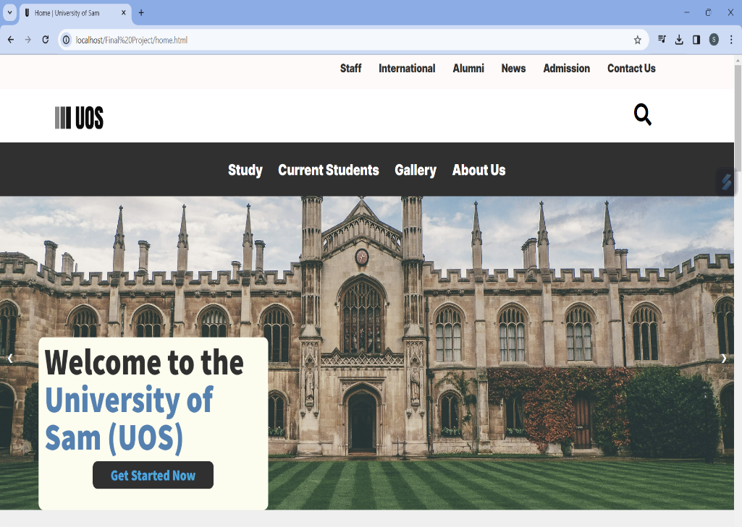

For the most recent news, events, and important details regarding UOS, visit our homepage.

Fig. 2.1. Home Page

1. **Academic Programs:**

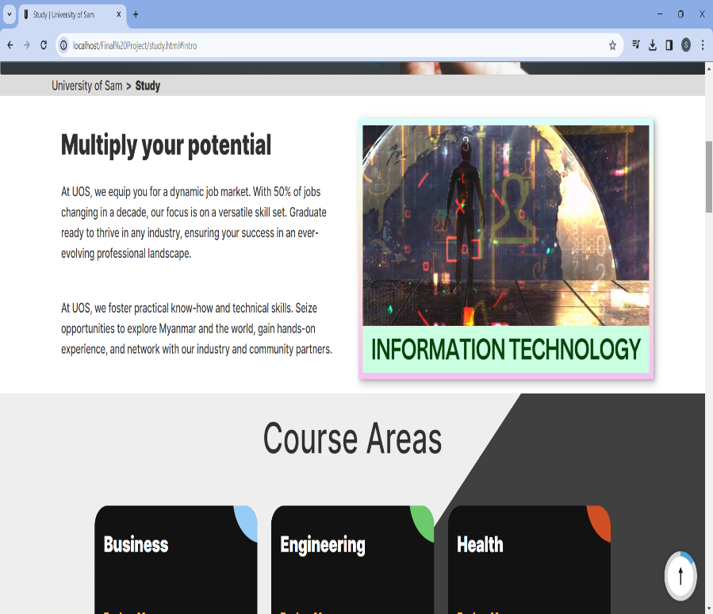

Dive into our diverse academic programs. Explore disciplines, and courses, and find the perfect fit for your educational goals.

Fig. 2.2. Study Page

1. **Student Portal Access:**

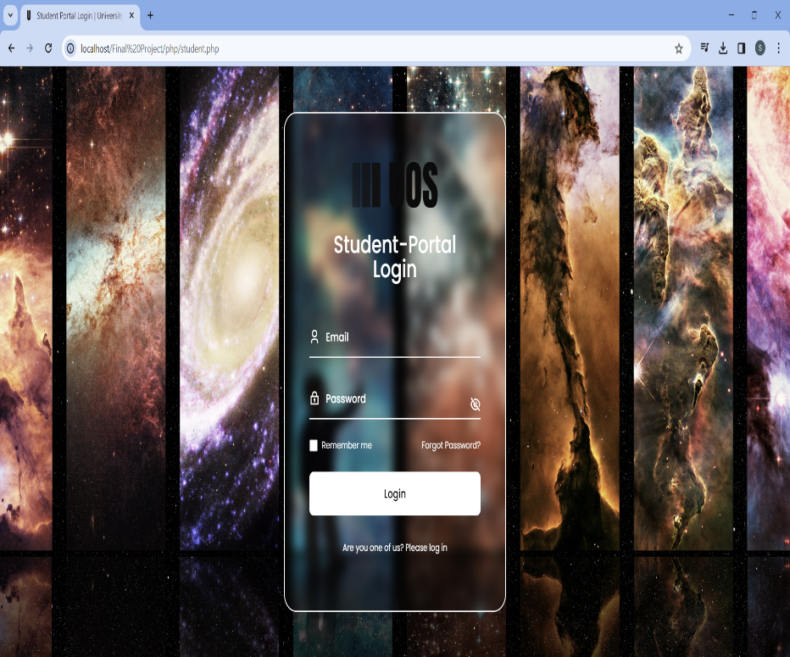

If you are a current student of ours, get access to the Student Portal, which serves as your main resource for educational materials, test results, and interactive exercises.

Fig. 2.3. Student-Portal Login Page

1. **Support Services:**

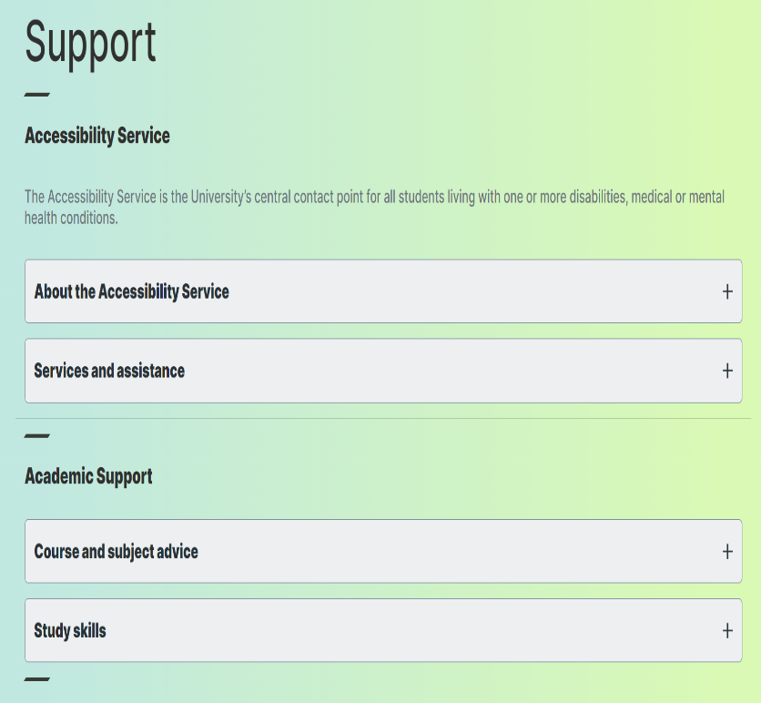

Examine the range of services available to support your professional and personal development. We can help you with everything from career guidance to therapy.

Fig. 2.4. Support Services

1. **Admission Information:**

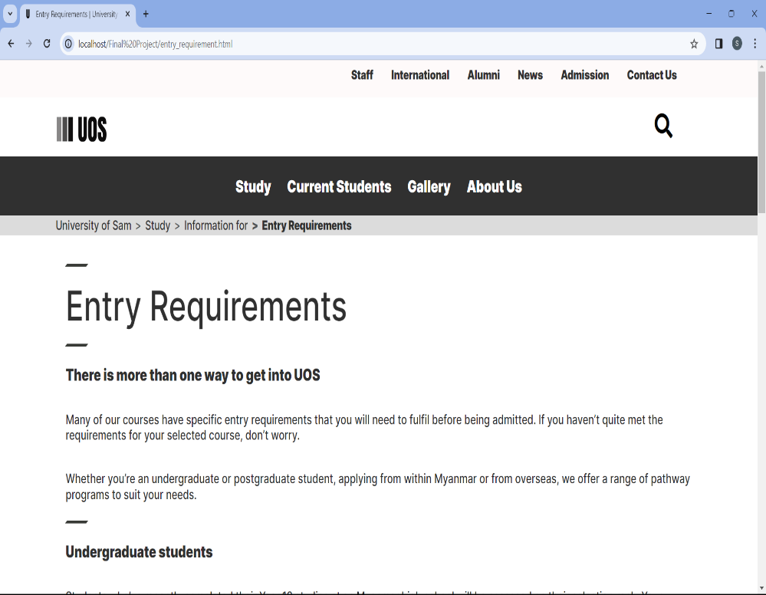

Find out everything you need to know about the application process, admissions requirements, and application forms if you're thinking about applying to UOS.

Fig. 2.5. Entry Requirements Page

1. **About UOS:**

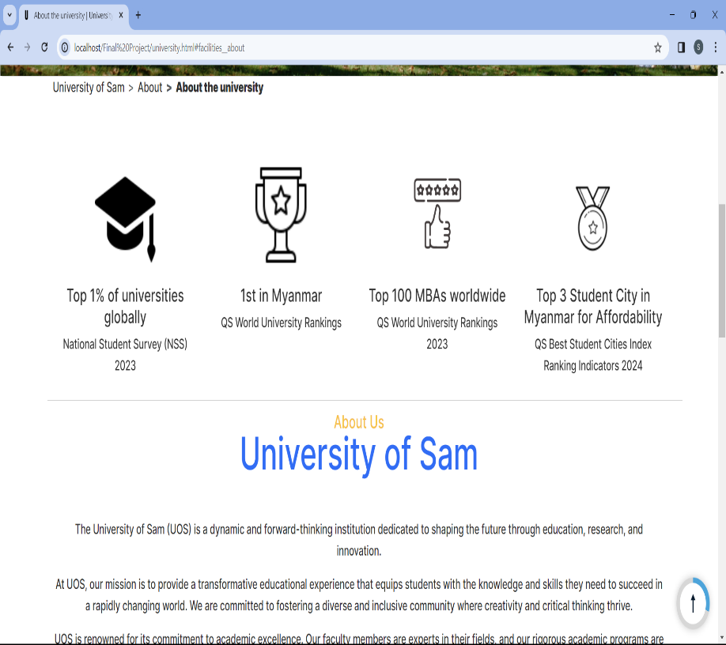

Discover our beliefs, mission, and dedication to excellence. Learn about the distinctive culture that makes up UOS.

Fig. 2.6. About UOS

1. **Contact Us:**

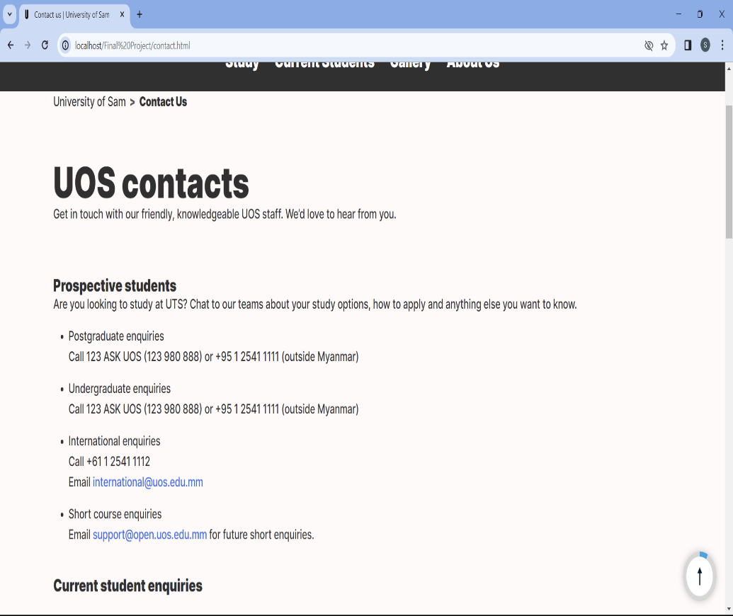

Get in touch with us if you have any questions or need help. We are available to assist you at every turn.

Fig. 2.7. Contact Us Page

**Your UOS Experience Awaits:**

* Greetings from a community that honours learning, creativity, and personal growth. Your journey through UOS, brimming with chances for personal development and exploration, is about to begin.

**Next Steps:**

* Either go through this guide in order or, depending on your interests, hop to particular sections. Explore at your leisure and settle into UOS as your academic home.

We appreciate you selecting UOS. Now let's get the adventure started!

## **Cautions and Warnings**

To guarantee a safe and secure experience, you must be aware of a few cautions and warnings as you begin your adventure with the University of Sam (UOS). Kindly be aware of the following:

1. **Account Security:**

* **Caution:** Keep your login credentials confidential.
* **Warning:** UOS will never contact you by email or in any other way to request your password. Avoid falling for phishing schemes.

1. **Data Privacy:**

* **Caution:** Use caution while disclosing information in public forums.
* **Warning:** UOS will never ask for private information via an insecure channel. Share personal information with prudence.

1. **Internet Security:**

* **Caution:** To access UOS online services, make use of reliable and secure networks.
* **Warning:** Public Wi-Fi networks could be dangerous. Steer clear of using insecure networks to access critical information.

1. **Academic Policies:**

* **Caution:** Familiarize yourself with UOS academic policies.
* **Warning:** Violating these policies may result in academic penalties.

1. **Copyright Compliance:**

* **Caution:** When using and disseminating scholarly resources, abide by copyright rules.
* **Warning:** Distribution or use of copyrighted materials without authorization may result in legal ramifications.

By following these admonitions and warnings, you help to make UOS a safe and courteous place. Report any suspicious behaviour or concerns you have to the UOS authorities right away.

## **Set-up Considerations**

To guarantee a smooth and ideal experience as you get ready to start your academic journey with the University of Sam (UOS), take into account the following setup considerations:

1. **Hardware Requirements:**

* **Examine your gadget:** To access UOS online resources, make sure your laptop, computer, or mobile device satisfies the minimal hardware requirements.

1. **Internet Connection:**

* **Stable connection:** To ensure continuous access to UOS services and resources, make use of a dependable, fast internet connection.

1. **Supported Browsers:**

* **Browser compatibility:** To get the most out of the UOS website and portals, make sure you are running a supported, current web browser.

1. **Secure Login Practices:**

* **Security of passwords:** For your UOS account, create a strong, one-of-a-kind password. Steer clear of using the same password on several sites.

1. **Virtual Private Network (VPN):**

* **Secure connections:** If you're using UOS services from a distance, think about utilizing a VPN to protect your connection, particularly if you're using free public Wi-Fi.

By taking care of these setup details, you lay the groundwork for a seamless and productive time at UOS. Please contact the UOS support staff for assistance if you run into any problems or need direction.

## **User Access Considerations**

To guarantee a safe and convenient experience, it's critical to comprehend the different access considerations for staff and students as you navigate the University of Sam (UOS) digital ecosystem.

1. **Staff Access:**

* **Privileged Information:** Staff members may have access to shared workspaces, administrative tools, and confidential data. Following security procedures is essential.
* **Profile Management:** Employees should maintain and update their profiles on a regular basis to ensure that contact information and roles within the organization are accurate.
* **Student Information and Exam Result Management:** Staff should acquire effective student data management skills to generate, upload, download, and share functions.

1. **Student Access:**

* **Academic Resources:** Students primarily access academic resources, course materials, and the Student Portal for exam results and interactive activities.
* **Profile Privacy:** Students should be alert about the privacy settings on their accounts, making sure that only the data that is required is shared with their peers.
* **Support Services:** Use the online resources for academic and personal development.

**User Access Best Practice:**

1. **Secure Login Credentials:**

* It is recommended that staff and students keep their login credentials secure and do not exchange passwords.

1. **Role-Based Access Control (RBAC):**

* RBAC should be used to make sure that users—staff and students alike—only have access to the data and resources that are necessary for their jobs.

1. **Regular Password Update:**

* Promote frequent password changes to improve account security.

1. **Two-Factor Authentication (2FA):**

* To add an extra degree of protection, especially for staff accounts that have access to sensitive data, think about introducing 2FA.

1. **Feedback Mechanism:**

* Provide a feedback channel where users may report problems, offer comments, and ask for help.

## **Accessing the System**

Three options will be available for system access:

1. **User (Guest) Access:**

* Launch your preferred web browser.
* Navigate to the UOS homepage.
* Examine publicly accessible areas outside of portals, such as news, events, courses, scholarships, and general information, without requiring identification.

1. **Staff Access:**

* Launch your preferred web browser.
* Navigate to the UOS Staff Portal.
* Enter your staff credentials to log in.
* Access staff-only collaborative spaces, student information and test results management tools, and administrative tools.
* Make sure security procedures are followed, and make sure your profile is updated on a regular basis.

1. **Student Access:**

* Launch your preferred web browser.
* Navigate to the UOS Student Portal.
* Enter your student credentials to log in.
* Use course materials, academic resources, and the Student Portal to access interactive exercises and exam results.
* Check frequently for announcements, updates, and student support services.

**Important Note:**

* Make sure the hardware and software requirements for your device are met.
* Make use of a dependable and steady internet connection to ensure continuous access.
* Observe any special instructions that UOS may supply you to use particular tools or capabilities.

Guests, staff, and students may all efficiently utilize the UOS system and ensure a safe and enriching experience by following these procedures and advice.

## **System Organization and Navigation**

### **System Organization**

UOS's system structure is painstakingly built to provide a smooth and effective digital environment that guarantees usability, security, and accessibility for every user. Here's a summary of the essential elements:

1. **Centralized Web Portal:**

* The UOS website serves as the central hub, providing a unified entry point for guests, staff, and students.
* The interface is easy to use, providing direct access to news, events, academic resources, admissions information, and more.

1. **User Authentication and Authorization:**

* Depending on the role of the user, a strong user authentication system guarantees safe access to various regions.
* Staff and students have access to features that are specifically relevant to their roles thanks to the implementation of role-based access control, or RBAC.

1. **Staff Portal:**

* Staff personnel have access to administrative tools, student information exam results management features, and collaborative areas through the Staff Portal.
* Organizational staff profiles facilitate effective collaboration and communication.

1. **Student Portal:**

* With access to course materials, exam results, interactive activities, and academic resources, the Student Portal is made with students in mind.

1. **Data Privacy and Compliance:**

* Respecting data privacy laws is essential to guaranteeing that user data is managed with the highest secrecy and compliance.

The way UOS's system is organized shows that it is dedicated to giving visitors, employees, and students access to a safe, effective, and inclusive digital environment.

### **Navigation**

#### **Navigation Bars**

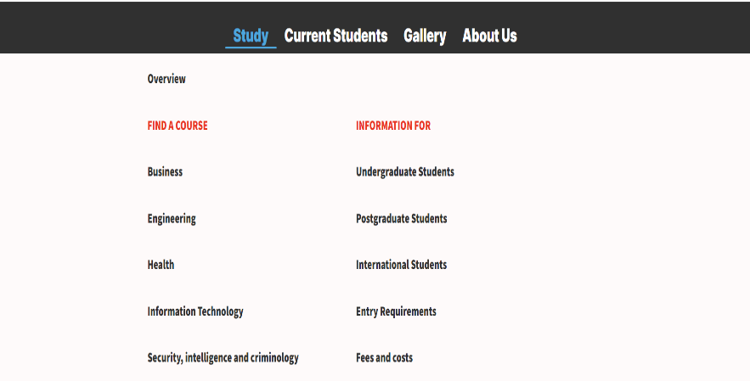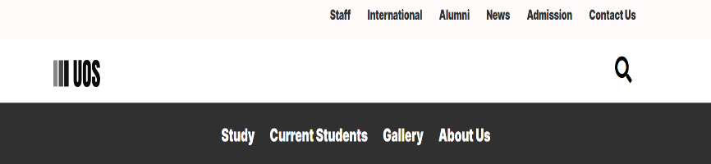

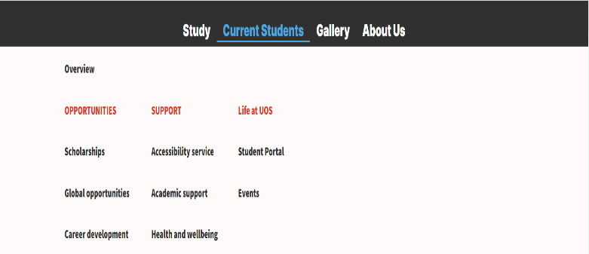

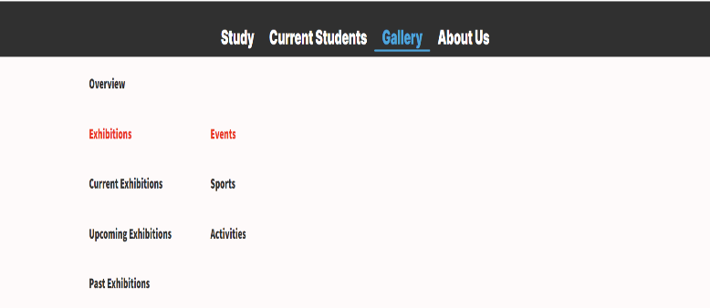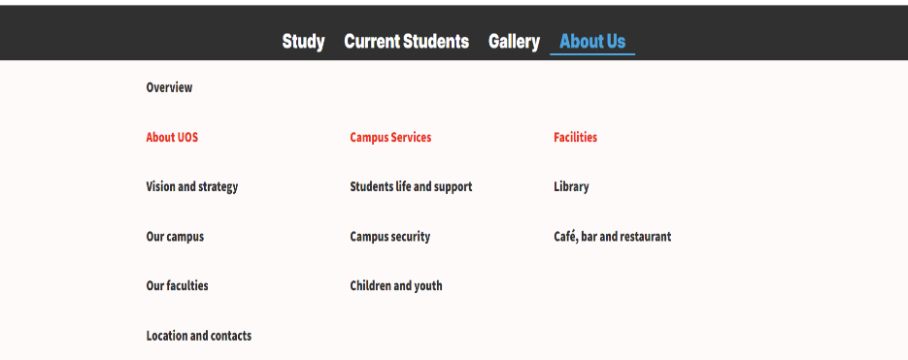

Fig. 2.8. Navigation Bars

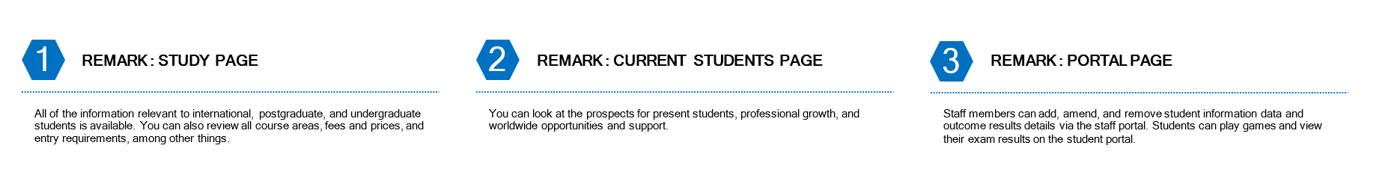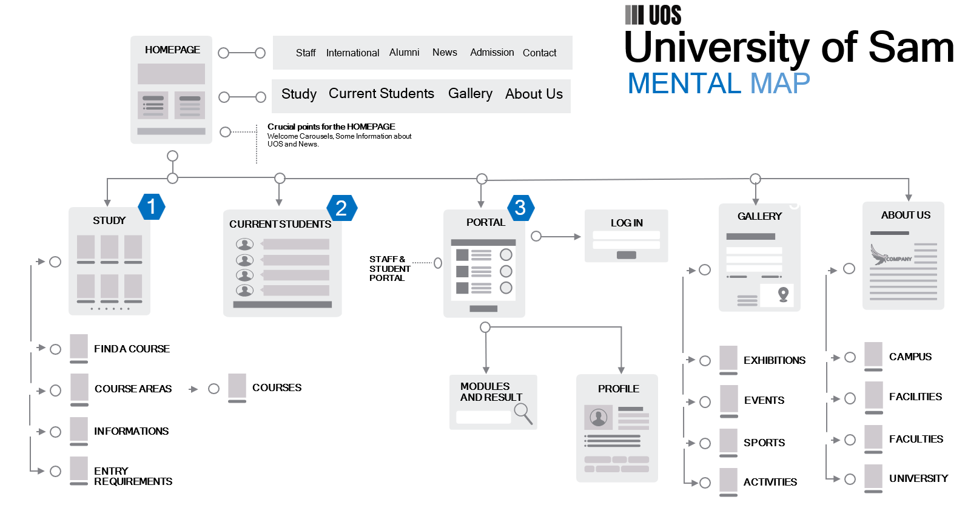 Here is a quick explanation of how those mental maps-based navigation bars function.

Fig. 2.9. UOS’s Mental Map

#### **Footer**

These are the most efficient methods of obtaining data in order to visit the relevant pages.

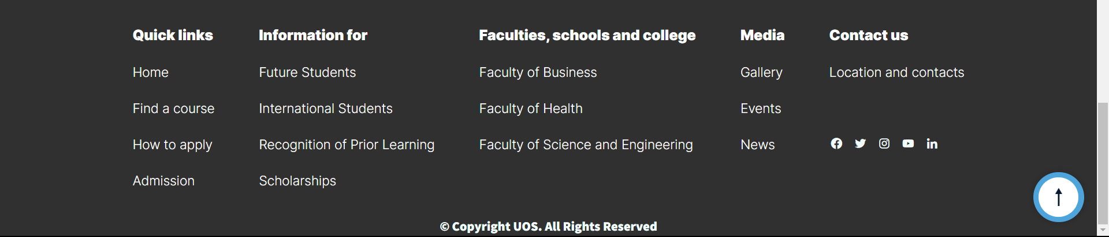

Fig. 2.10. Footer

#### **Search Box**

Every page can be found using the search box.

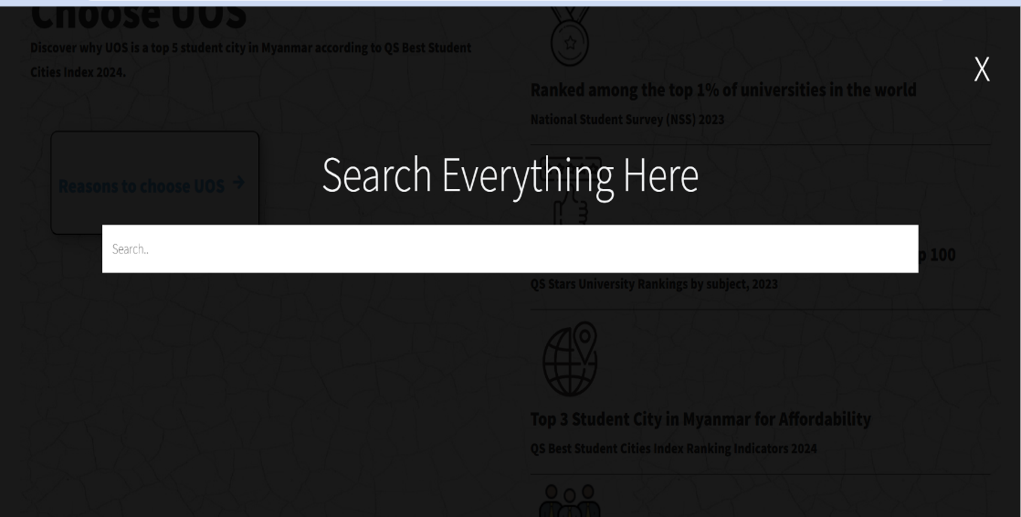

Fig. 2.11. Search Box and Search Action

#### **Find a Course**

All of the courses and modules that UOS offers are available. Here, you may assess them by typing the names of the courses.

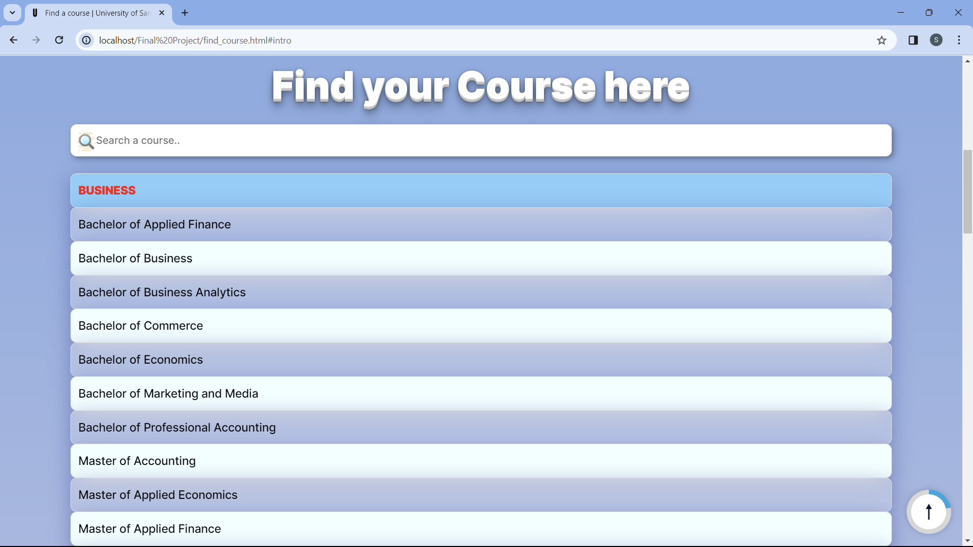

Fig. 2.12. Find a Course Page

## **Exiting the System**

The UOS system's exit procedure is simple and easy to use, with security and convenience in mind. Here are the procedures for a safe exit, regardless of whether you are a visitor, employee, or student:

1. **User (Guest) Exit:**

* For guests exploring public areas, simply close the web browser to exit the UOS website.

1. **Staff Exit:**

* When finishing their work, employees should log out of the Staff Portal.

1. **Student Exit:**

* Students should log out of the Student Portal and close the web browser.

Users can confidently quit the UOS system, guaranteeing the security of their digital experience and the preservation of their data, by adhering to these procedures and security measures.

# **Using the System**

## **Home**



It will lead you to the main section of this page



It will bring you to the “Study” page

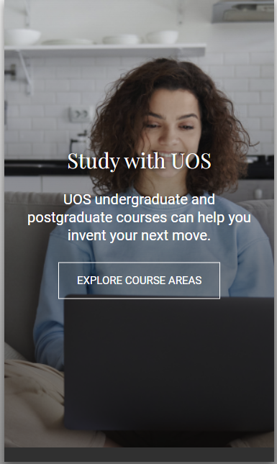

This button is marked "up-to-top." The height of the page that you are scrolling over is indicated by the border color.

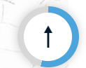



It will bring you to our “Faculty” page

It will bring you to our “Alumni” page

You can learn our “About us” page by clicking this button.

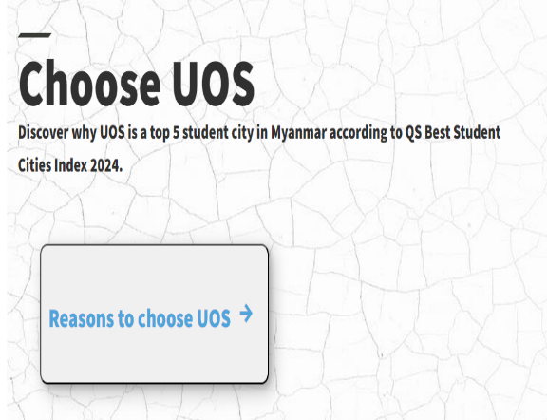

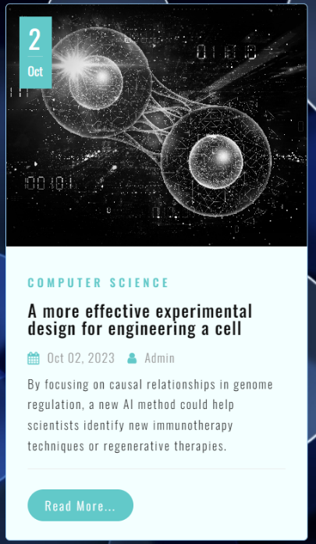

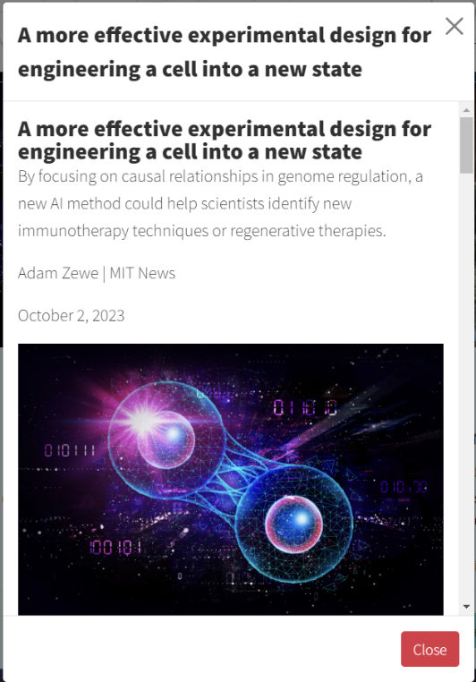

By clicking this button, the following modal will be displayed.

## **International**

You can come to the “International” Page by clicking this in navigation bar.





It will bring you to the “Admission” Form



It will bring you to the “Fees and costs” section

It will bring you to the “Study” Page

You'll reach the "Find Courses" section as a result. Courses can be found by name.

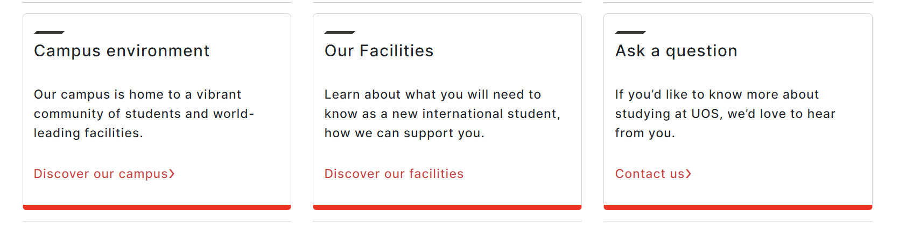

It will bring you to the “Contact Us” page

It will bring you to the “About our campus” Page

It will bring you to the “About our facilities” page

## **Alumni**

It will bring you to the “News” page

It will bring you to the “Contact Us” page

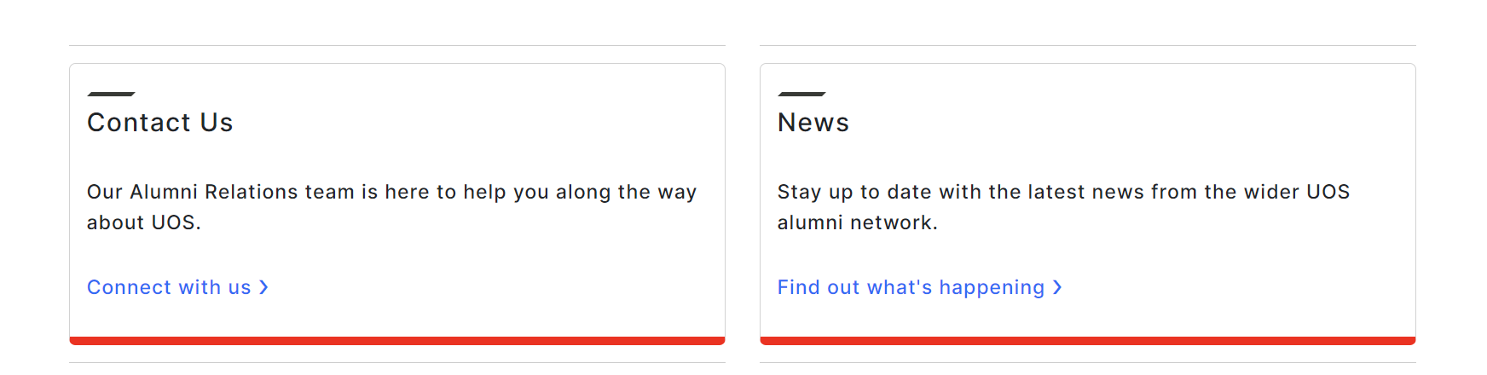

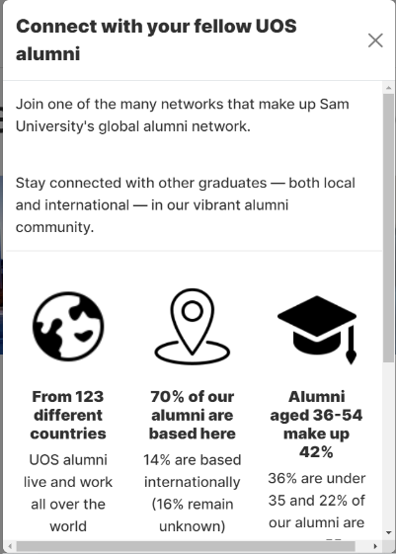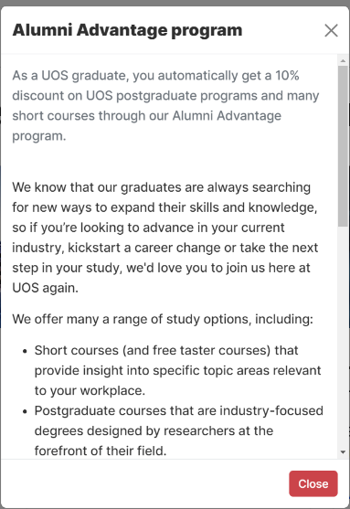

By clicking this, the following modal will be displayed.

By clicking this, the following modal will be displayed.

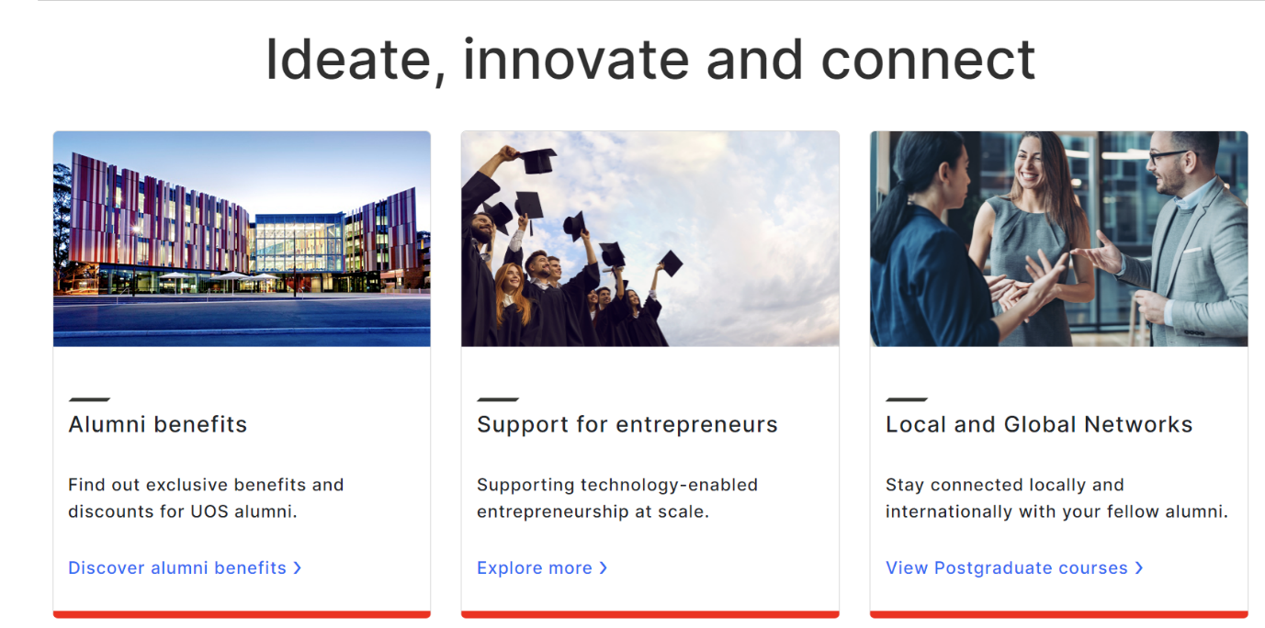

By clicking this, the following modal will be displayed.

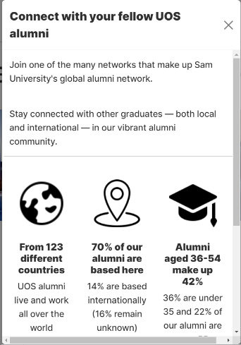

## **News**

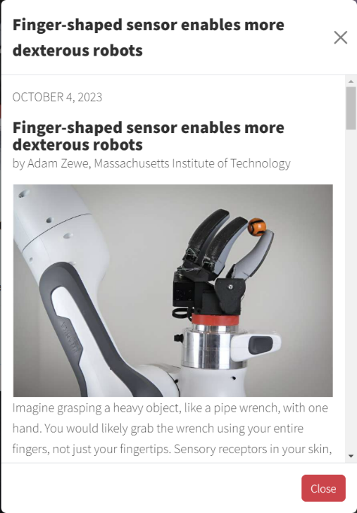

Clicking this button will bring up the following pop-up, similar to the "Home" Page.

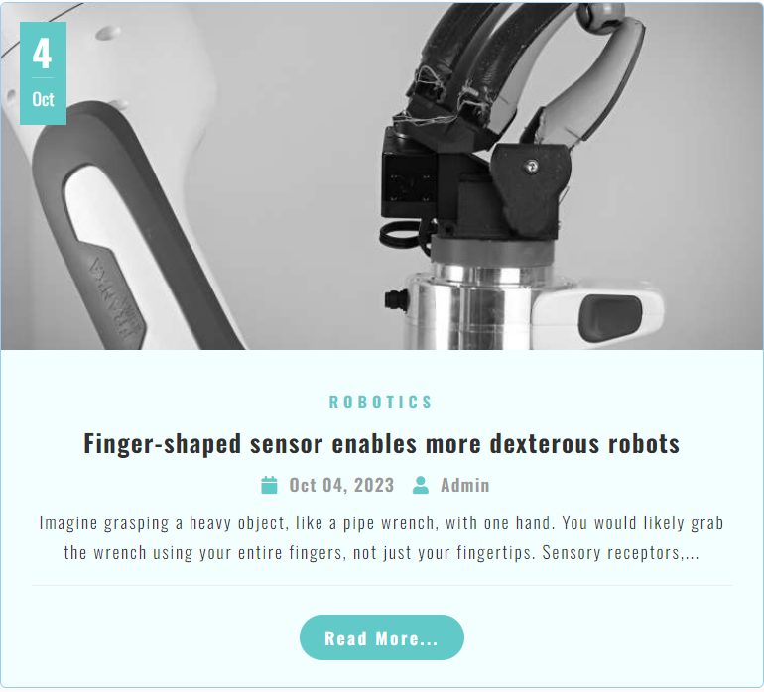

## **Admission**

To send us an email with inquiries, fill out this form and press the submit button.

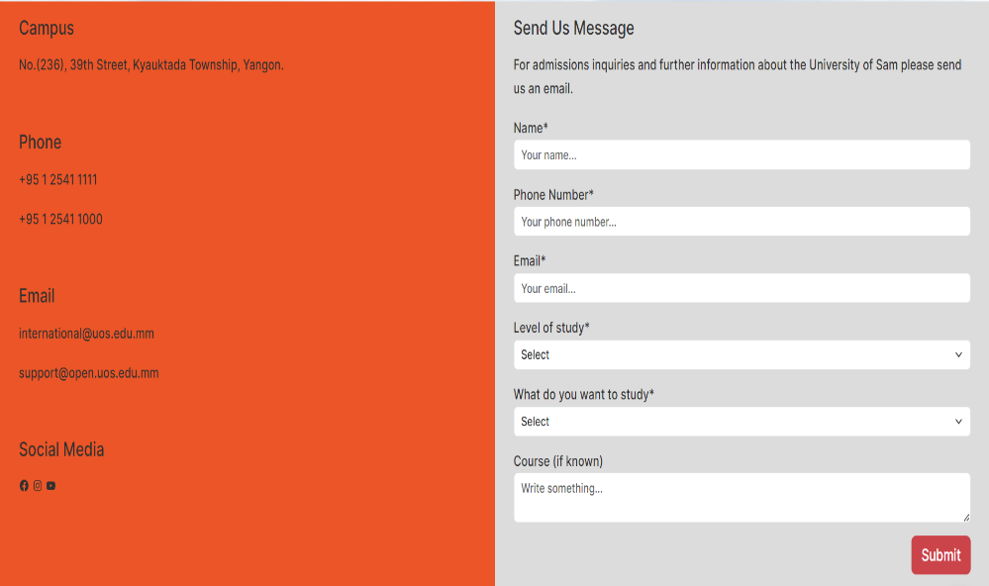

## **Contact Us**

Similar to the admissions page, to send us an email with inquiries, fill out this form and press the submit button.

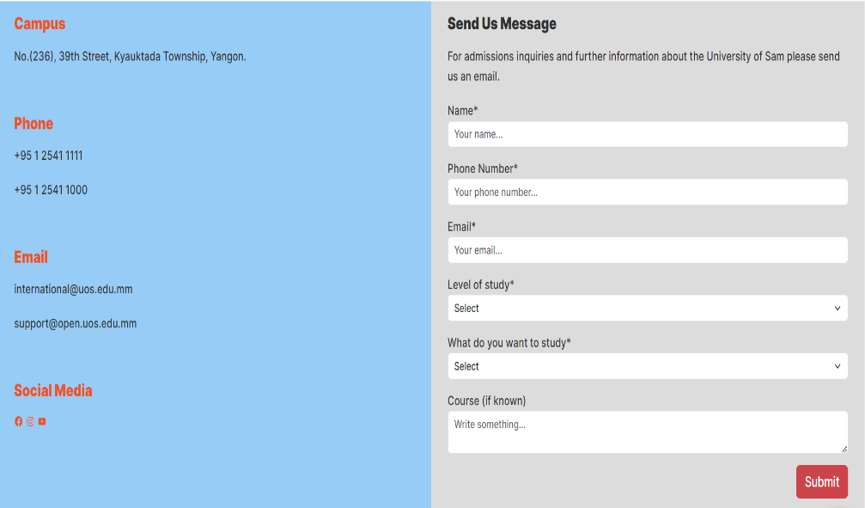

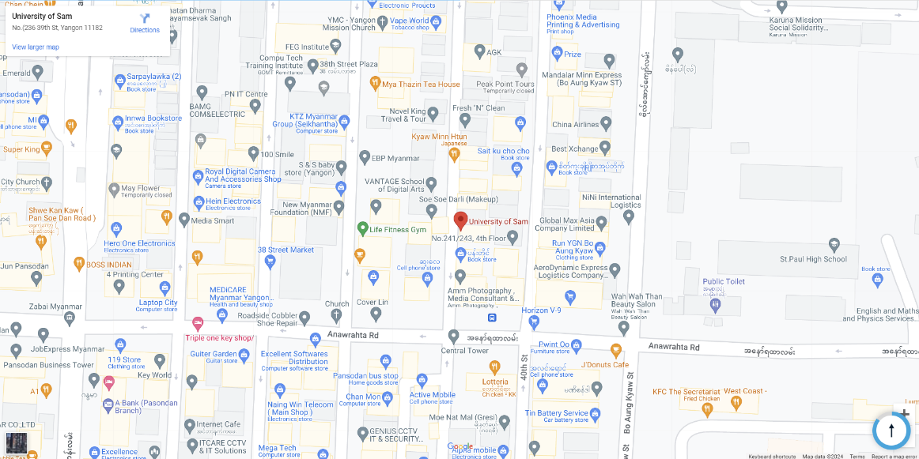

This is where we are on a Google map. You can look for our campus by clicking.

## **Study**

This is the video we utilized to introduce ourselves. You can click this to make it larger.



It will bring you to the “Engineering” page

It will bring you to the “Business” Page

It will bring you to the “Health” page

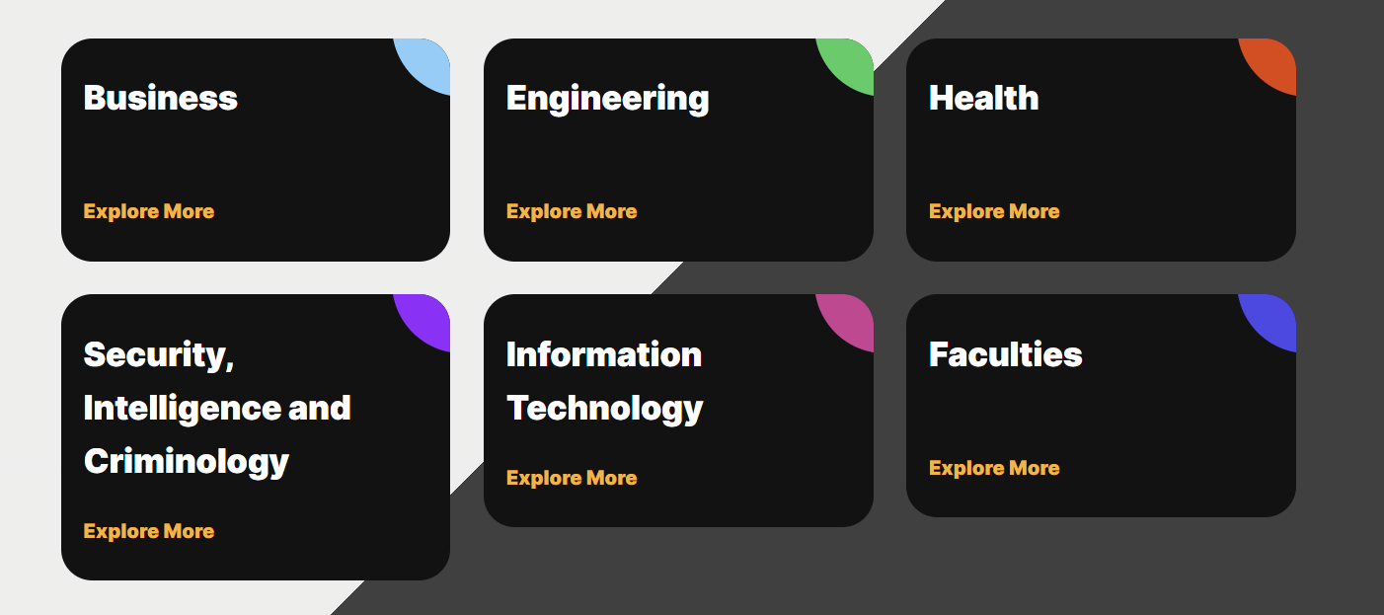

It will bring you to the “Security, Intelligence and Criminology” Page

It will bring you to our “Faculties” page

It will bring you to the “Information Technology” page



Information regarding "Undergraduate", "Postgraduate", and "International" is available.

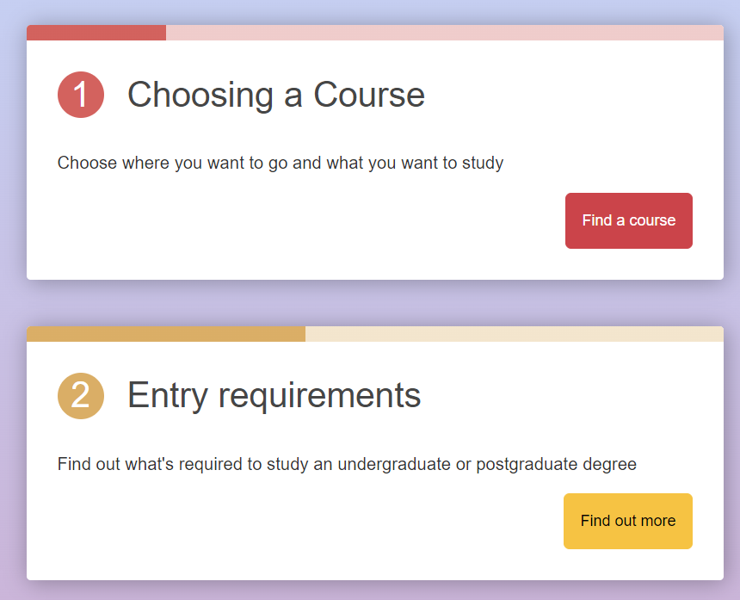

You can review our course programs' "Entry Requirements"

You'll reach the "Find Courses" section as a result. Courses can be found by name.

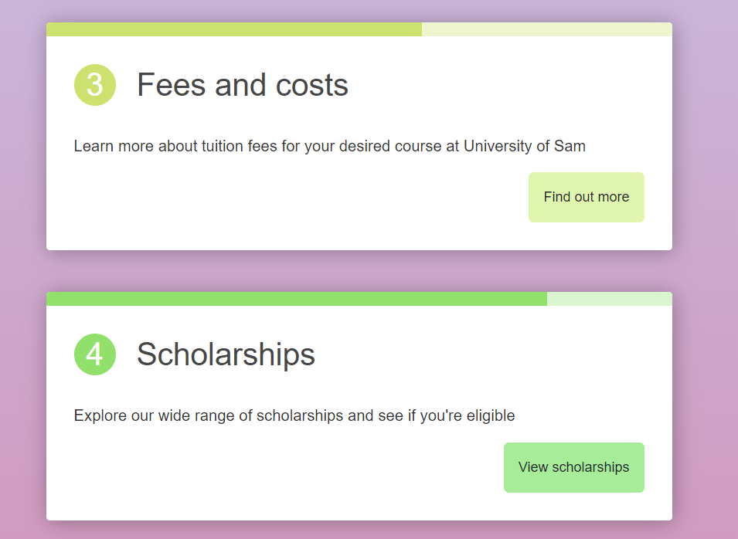

You can review our course programs' "Fees and costs" section.

View our scholarships available for domestic and international students.

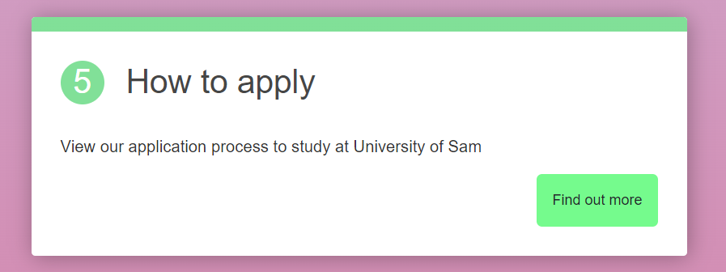

Take a look at this to learn "How to apply" for our programs.

### **Business**

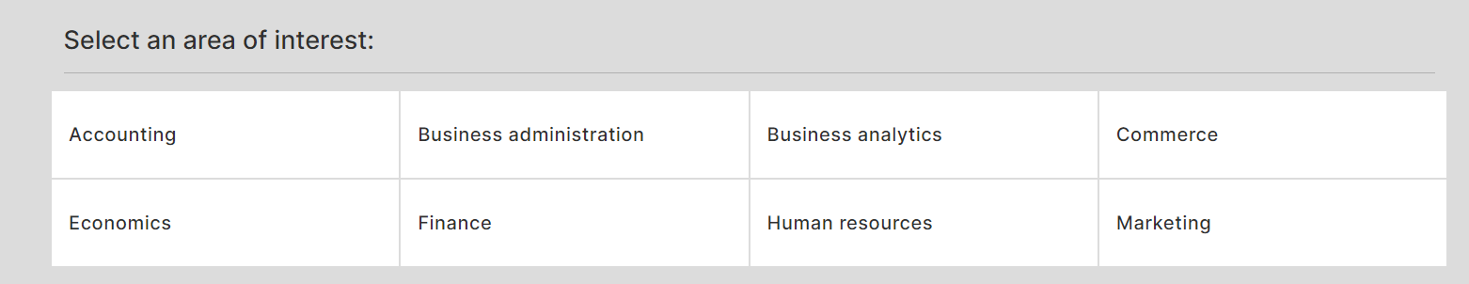

To find out more about those areas of interest and the programs they offer, click on respective buttons.

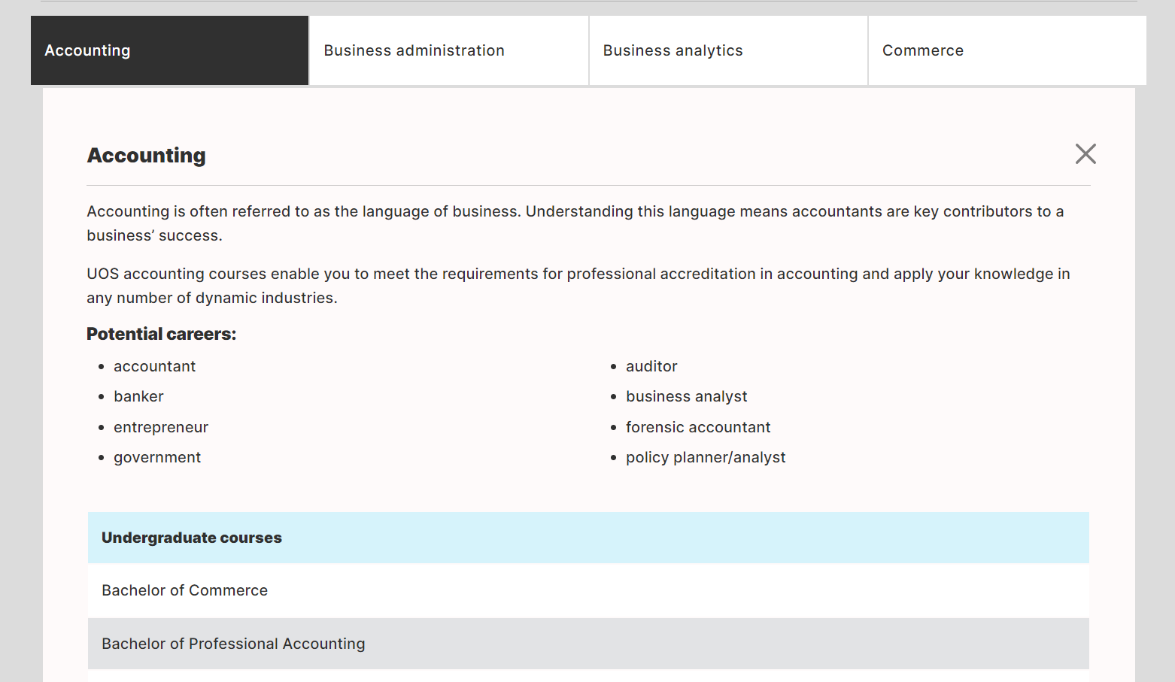

You can visit those links to find out more about the program's details.

### **Engineering**

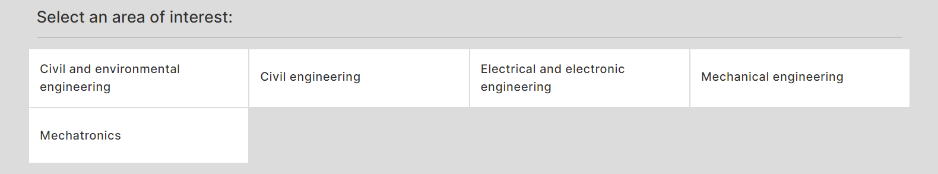

As before, click the corresponding links to learn more about those programs and areas of interest.

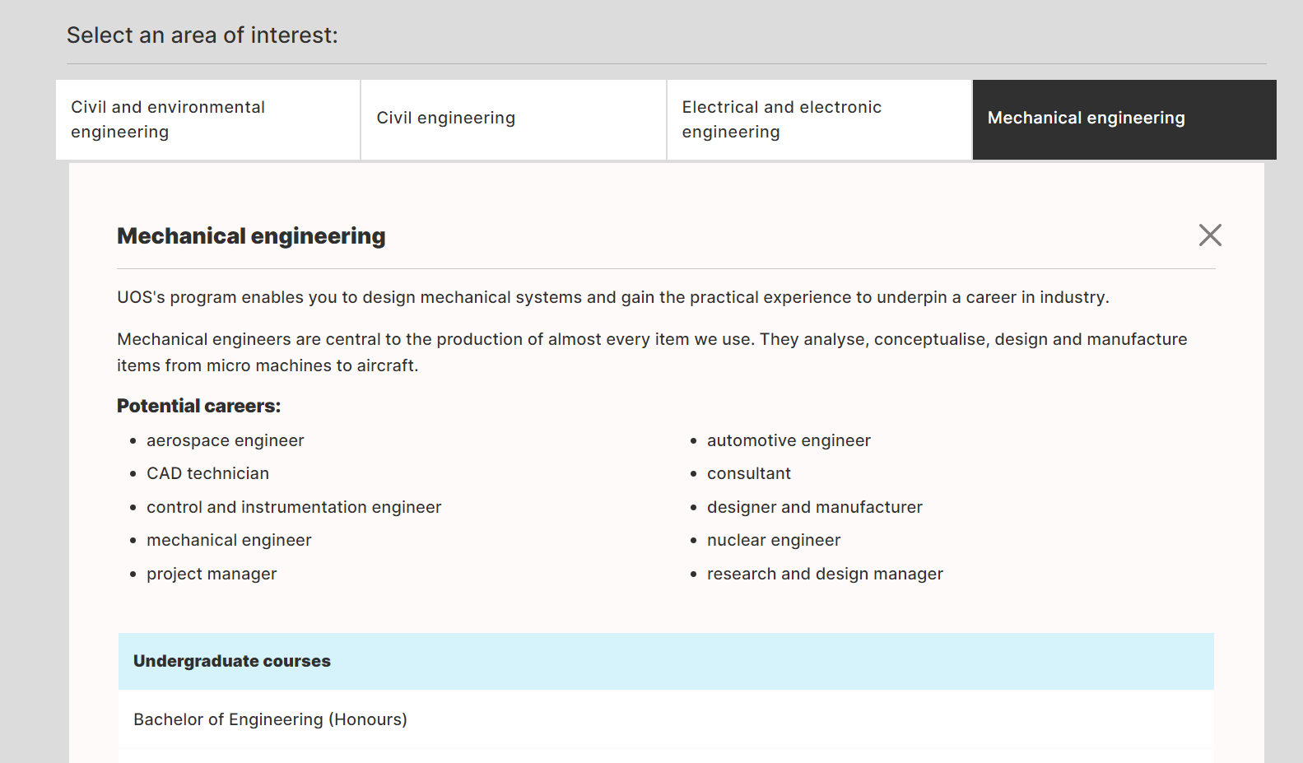

You can visit those links to find out more about the program's details.

### **Health**

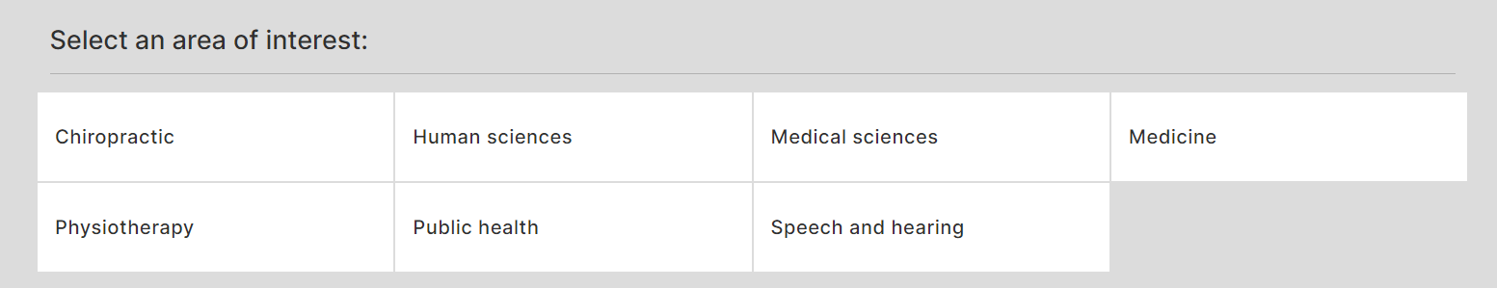

As before, click the corresponding links to learn more about those programs and areas of interest.

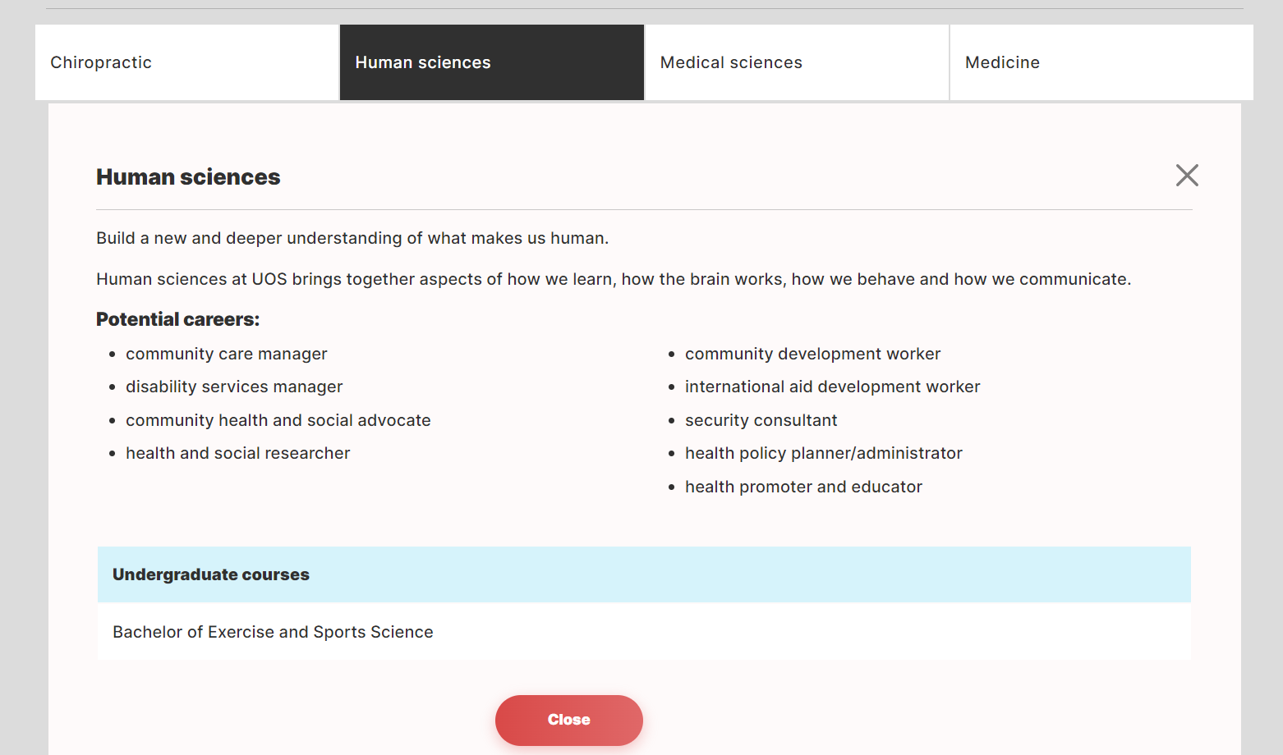

You can visit those links to find out more about the program's details.

### **Information Technology**

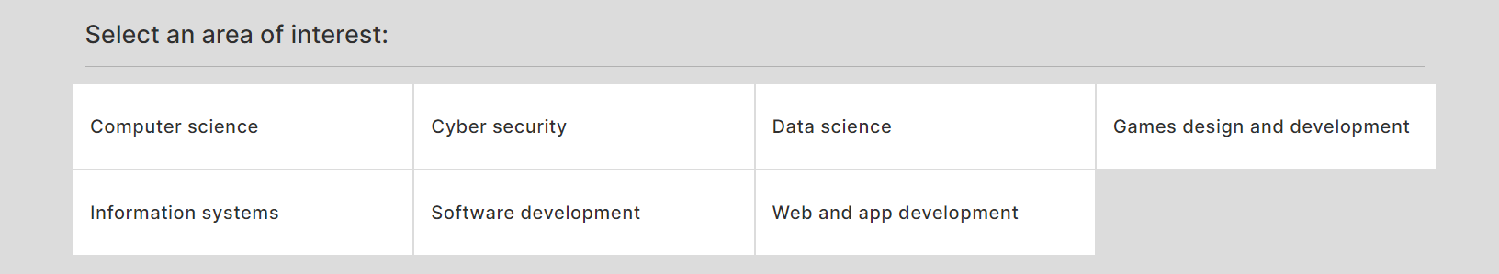

As before, click the corresponding links to learn more about those programs and areas of interest.

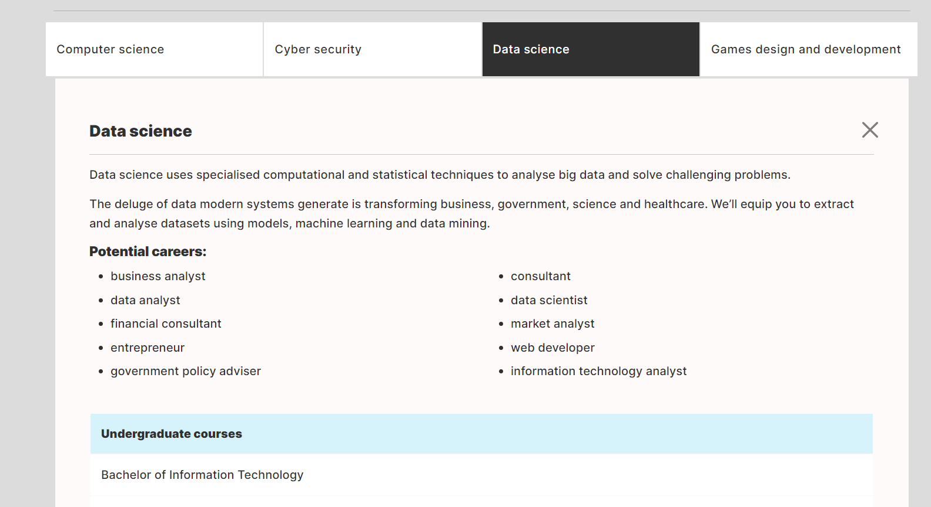

You can visit those links to find out more about the program's details.

### **Security, Intelligence and Criminology**

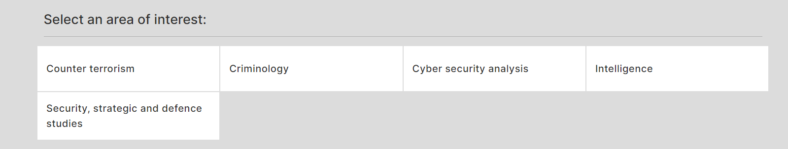

As before, click the corresponding links to learn more about those programs and areas of interest.

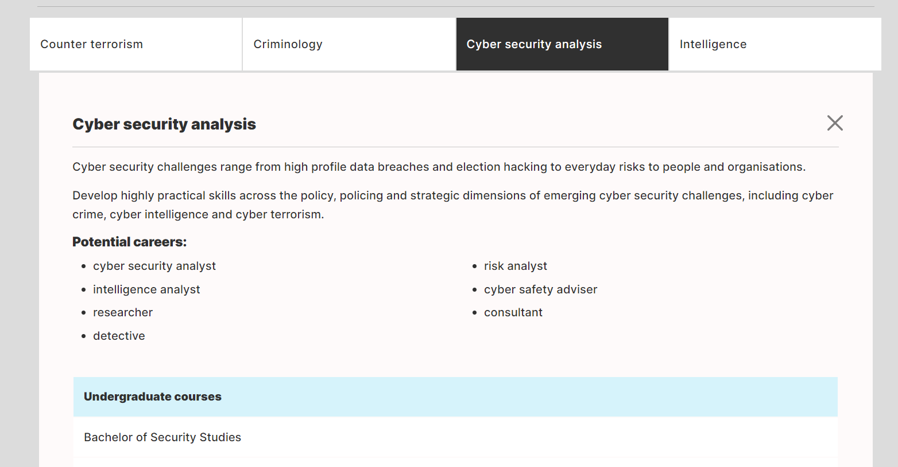

You can visit those links to find out more about the program's details.

### **Information for Students**

The "Information for Students" sample looks like this. These buttons will take you to the relevant pages. Click them.

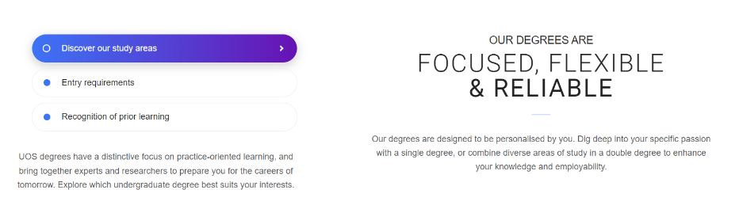

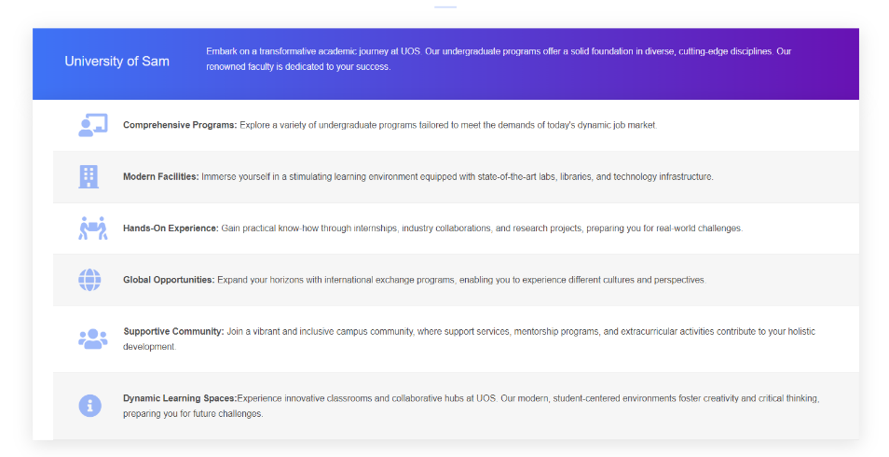

### **Entry Requirements**

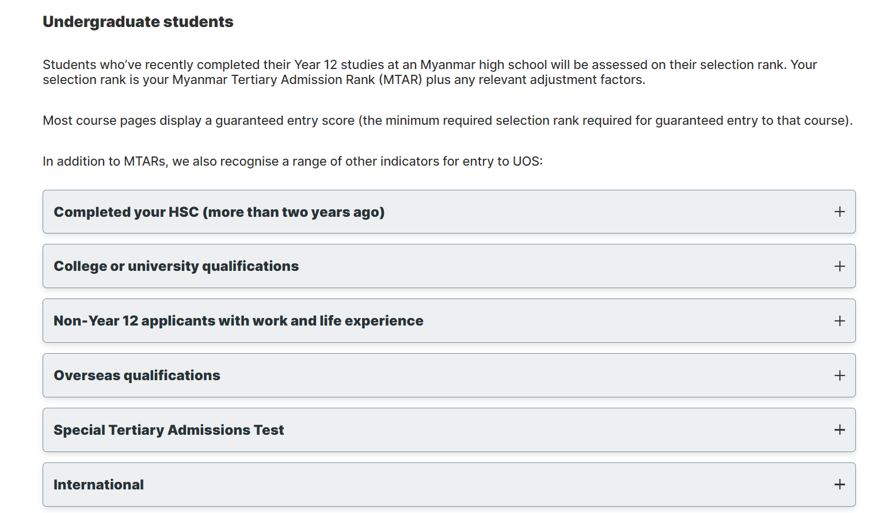

This is an example of the entry requirements as well. Clicking those will allow you to read more.

### **Fees and costs**

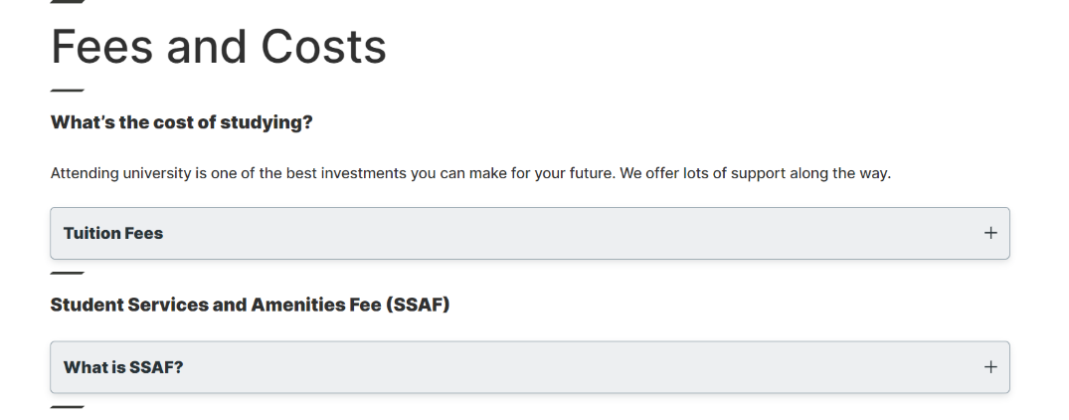

The following fees will appear if you click those.

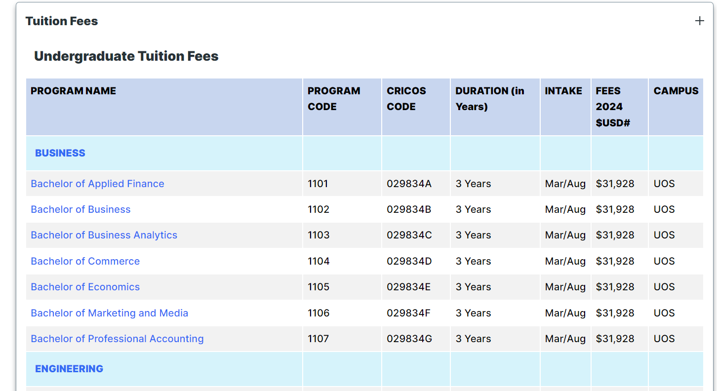

By clicking those data, you may also access the associated programs.

### **Find a Course**

By typing the names of the courses here, you can search for them however you'd like.

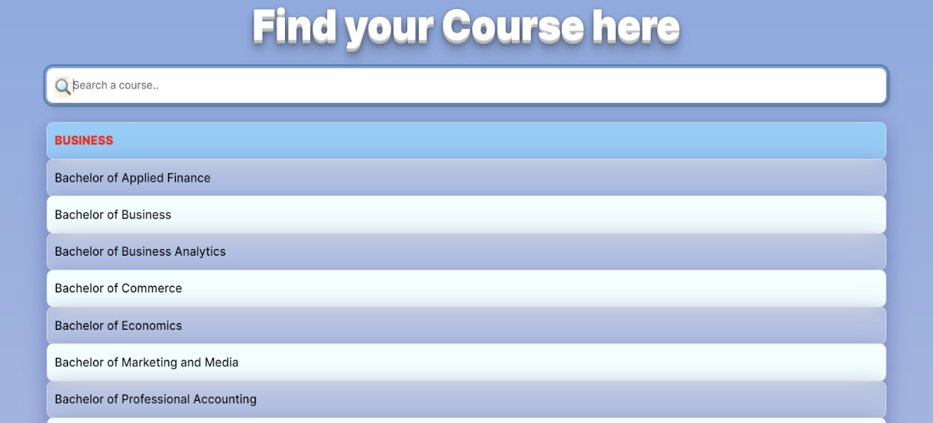

By clicking those data, you may also access the associated programs.

### **Courses**

This is an example of a course page.

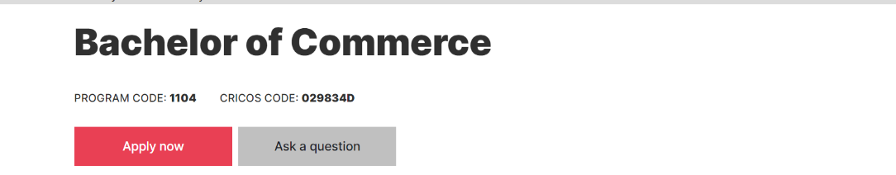

It will bring you to the “Admission” Page

It will lead you to the “Contact Us” page



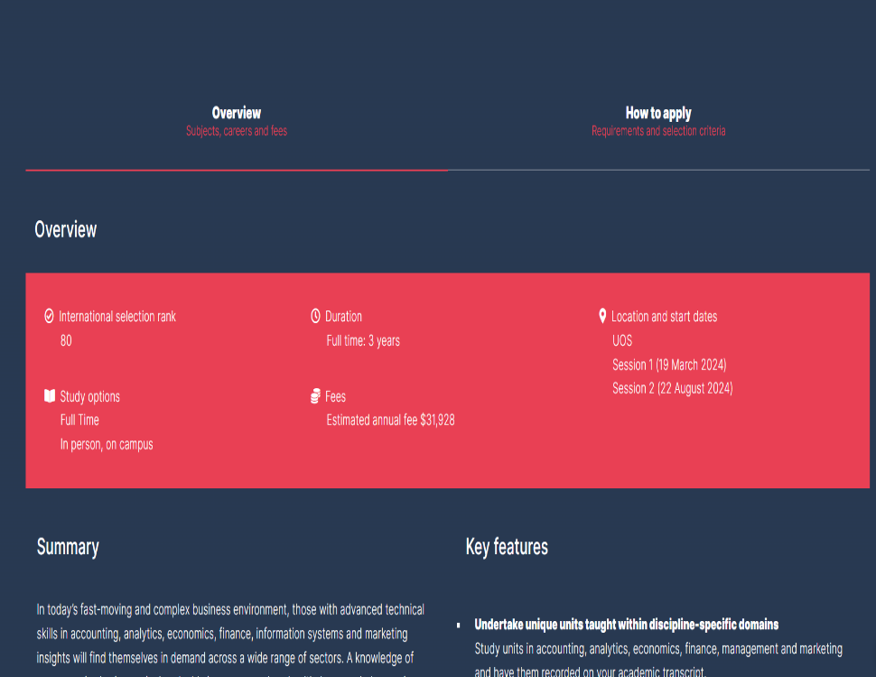

By clicking those buttons, the pages that follow will open, allowing you to view detailed information on the course.

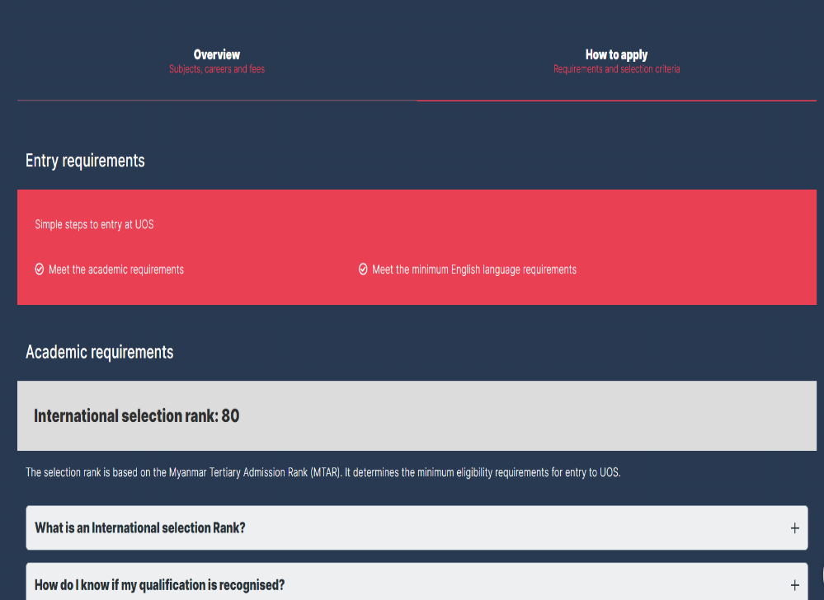

## **Current Students**

These cards will show a brief description when you hover over them, and clicking them will take you to the relevant pages.

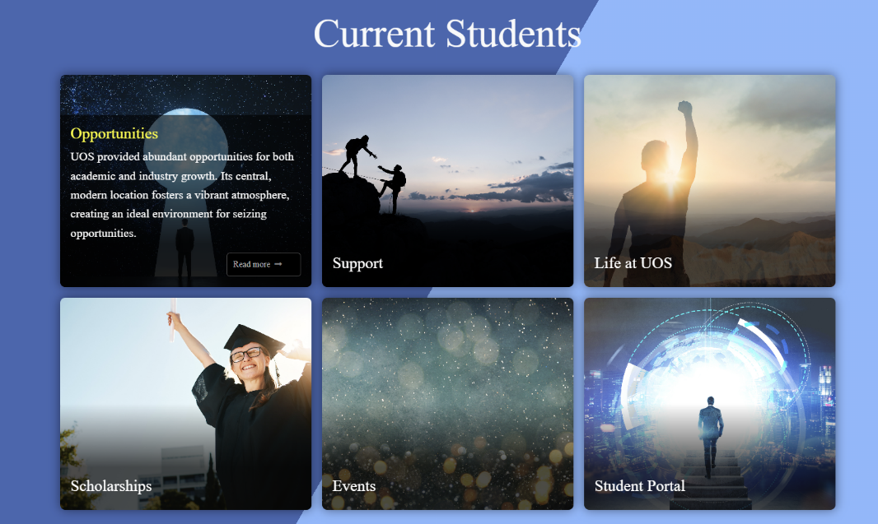



By clicking on those items and expanding, you can learn more.

### **Scholarships**

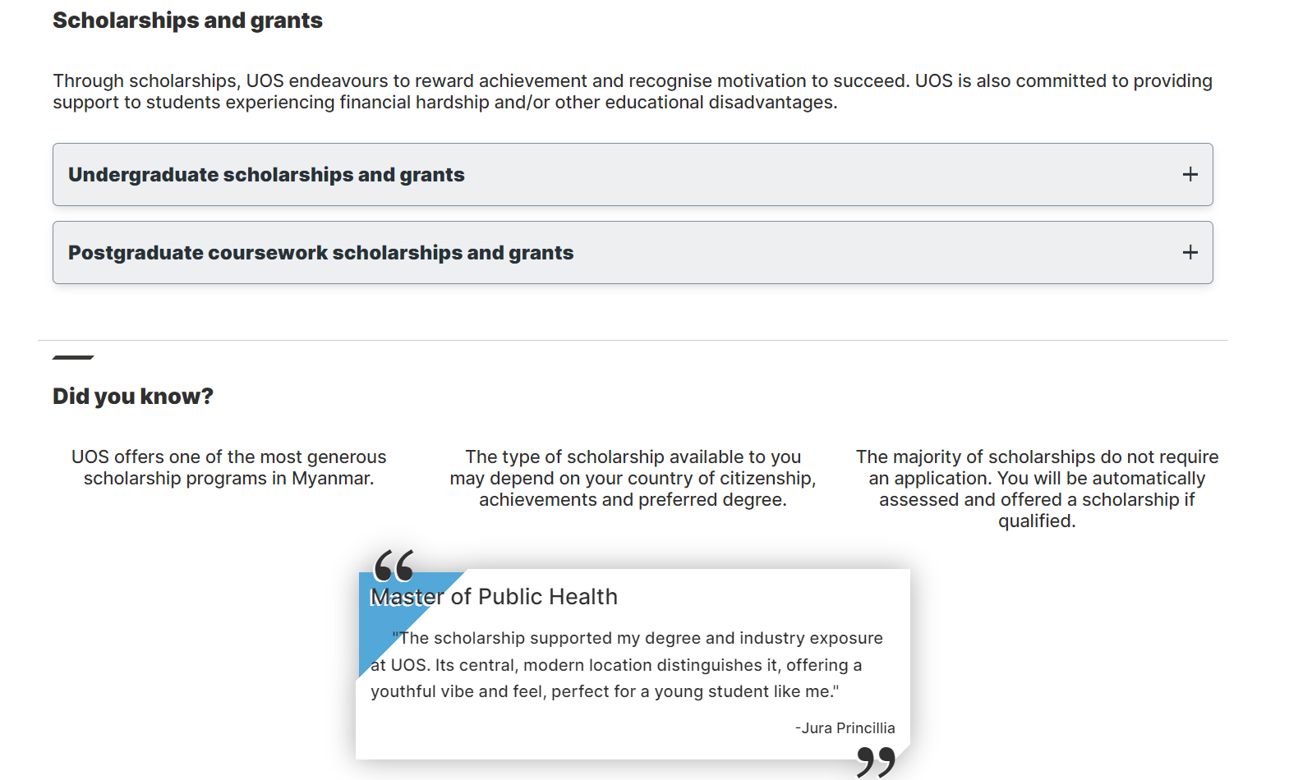

This is the scholarship page; upon clicking, the information below will appear.

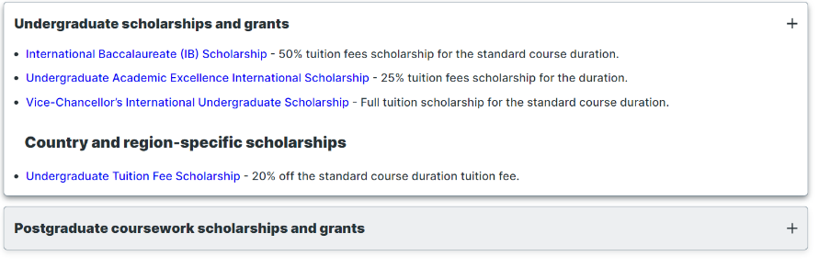

When you click those links, the following pop-up modal will appear.

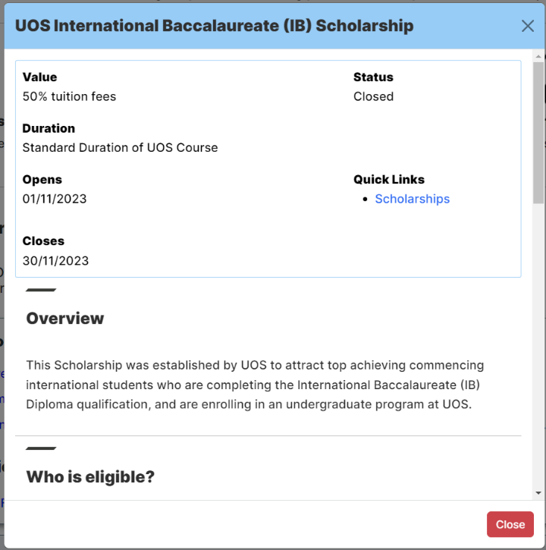

## **Gallery**

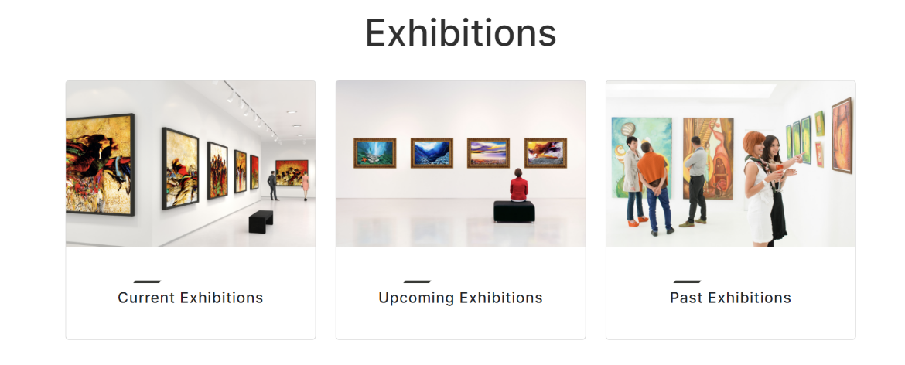

The gallery page was crammed with images and slide shows. You can access the relevant sections by clicking there.

This is an illustration of a gallery part; upon clicking the image, the modal that follows will appear.

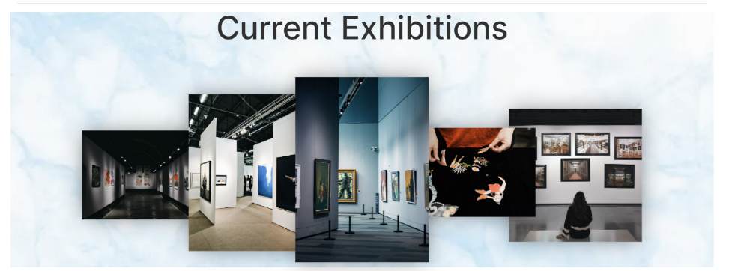



## **About Us**

The relevant pages will be pointed if you click those.

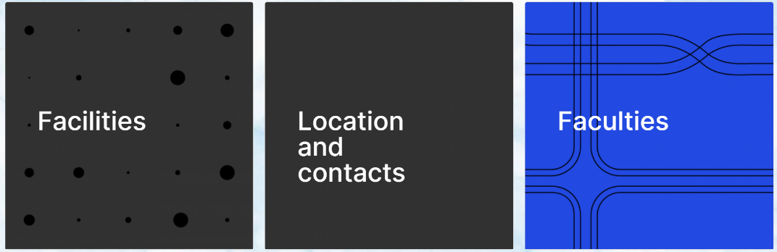

### **Faculties**

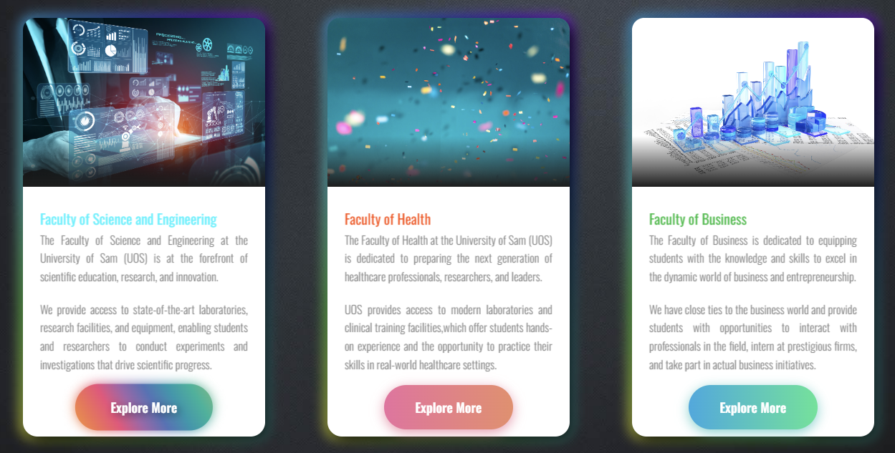

The Faculty Page is located here. The synopsis is currently visible. Press the buttons to get more information.

#### **Faculty of Business**

To access the corresponding pages, click those cards.

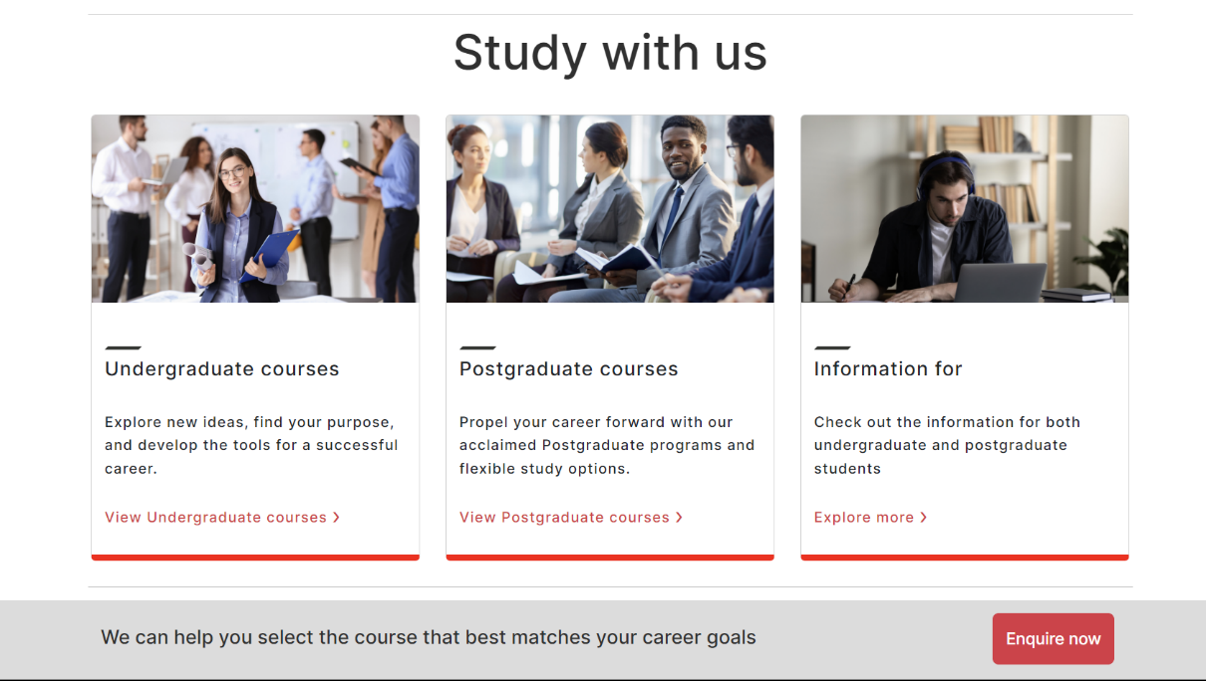

You can click the button to get in touch with us.

#### **Faculty of Health**

A small description will appear when you hover over the card, and clicking "explore more" will take you to the next page.

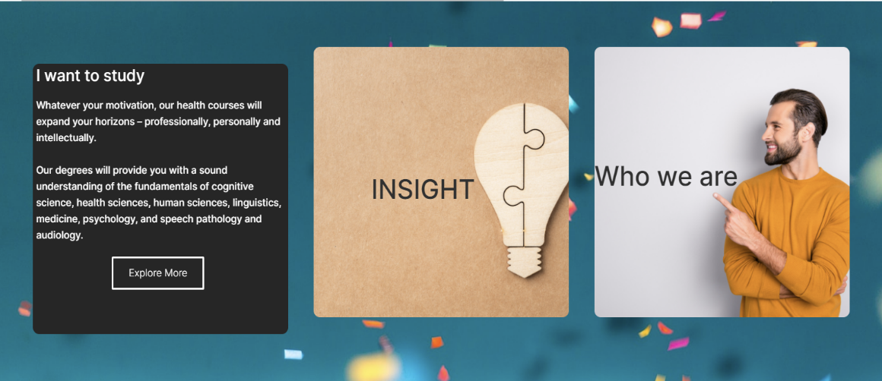

#### **Faculty of Science and Engineering**



This part welcomes you and features some animations. Clicking the button will take you to the next section.



Clicking on such cards will cause them to enlarge and reveal the button.

These buttons will take you to the appropriate sites.

## **Staff Portal**

You can come to the “Staff Login” Page by clicking this in navigation bar.



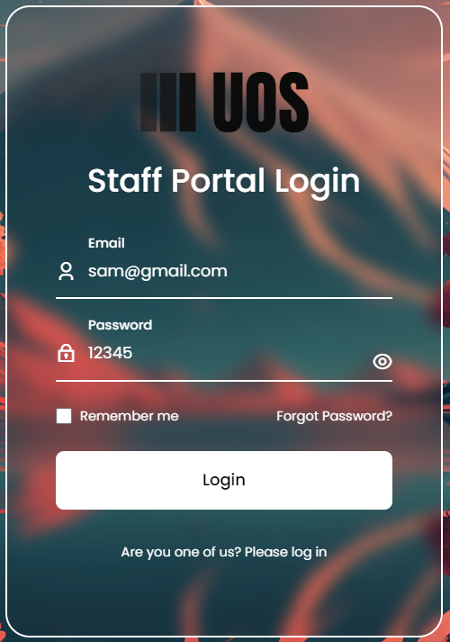

The staff login page is this. Once you entered your details, the staff portal was accessed. You can hide or display the password with this eye symbol.

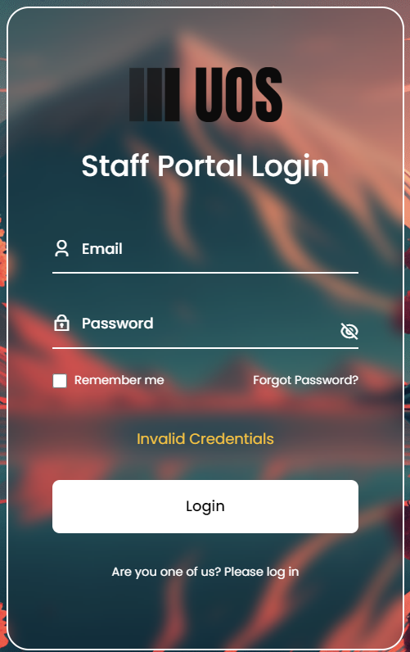

The following notice will appear if you enter your password or email incorrectly, and you will need to try again.

Additionally, by clicking this, you can view, amend, or log out of your profile.

This is the staff portal's dashboard page. By using those navigation buttons, you can navigate to a different section.

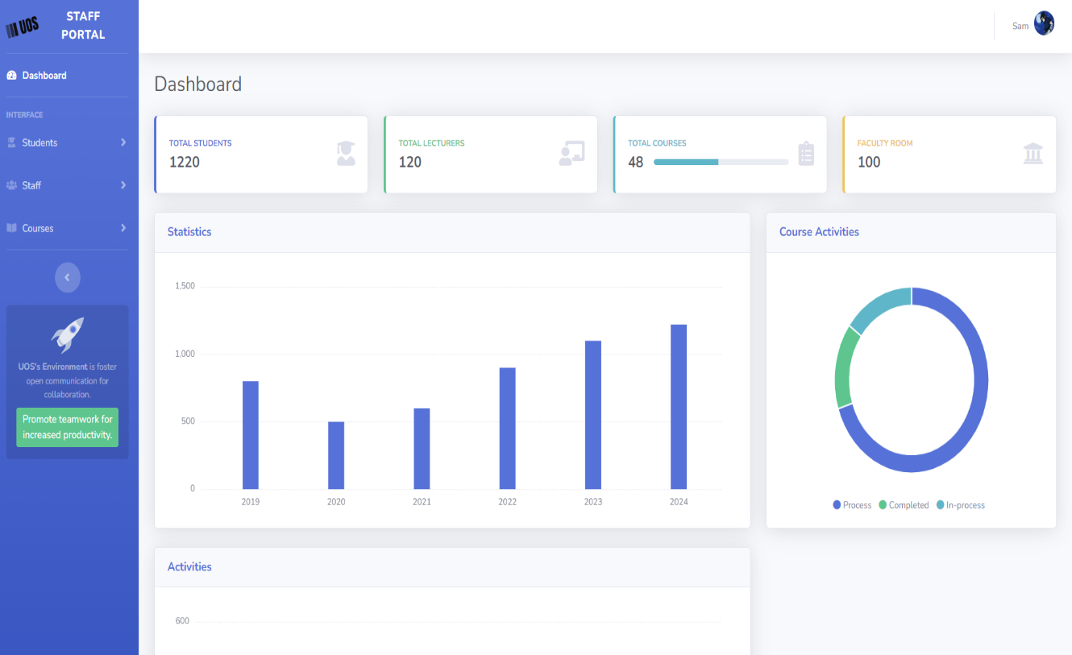

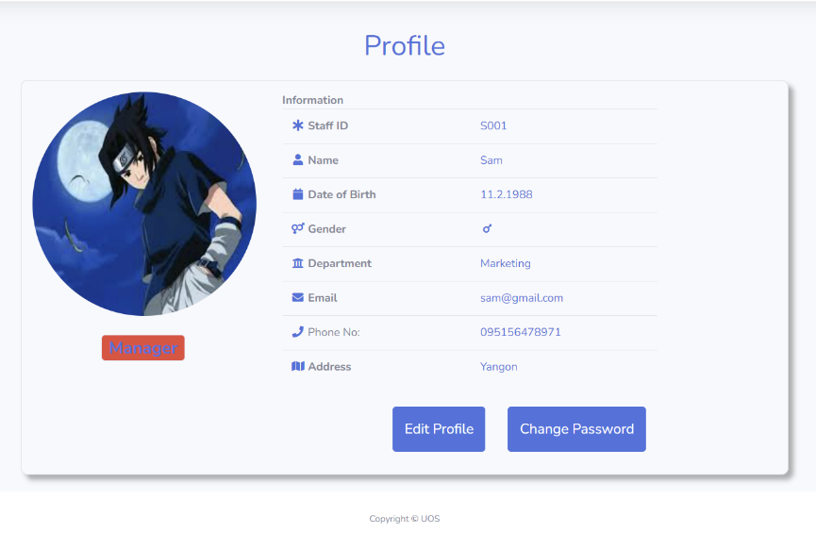

Only in the event that the new password is a strong password will the Submit button appear.

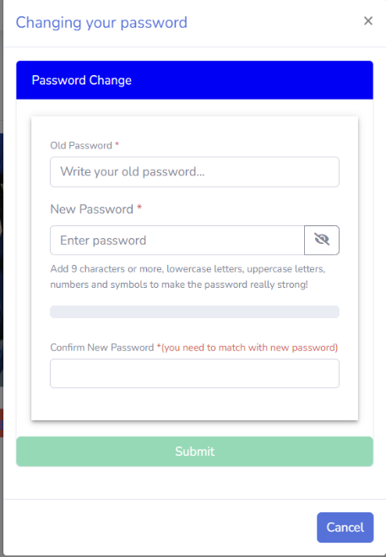

Your own profile will appear; click the edit button if you would like to make changes. As an example, I'll show you the Change Password Button here.

All staff information is contained in this section. The Plus Sign Button is used to add employees.

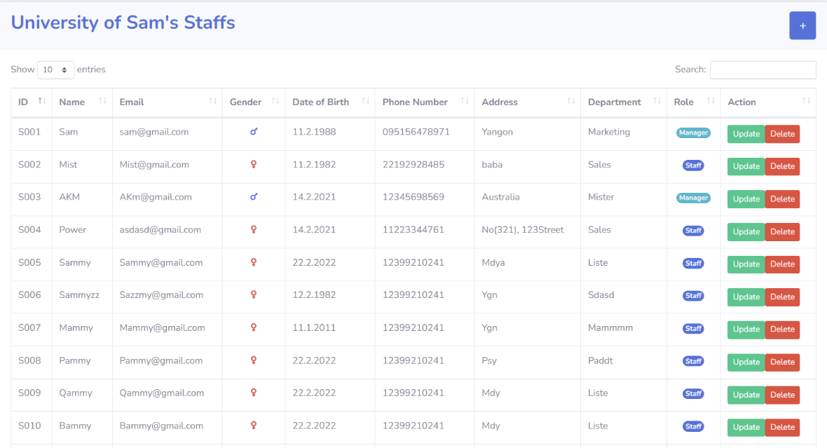

If you are not a manager, those Update and Delete Buttons will not be shown.

Students' profile images cannot be uploaded; only staff members' profiles may be uploaded.

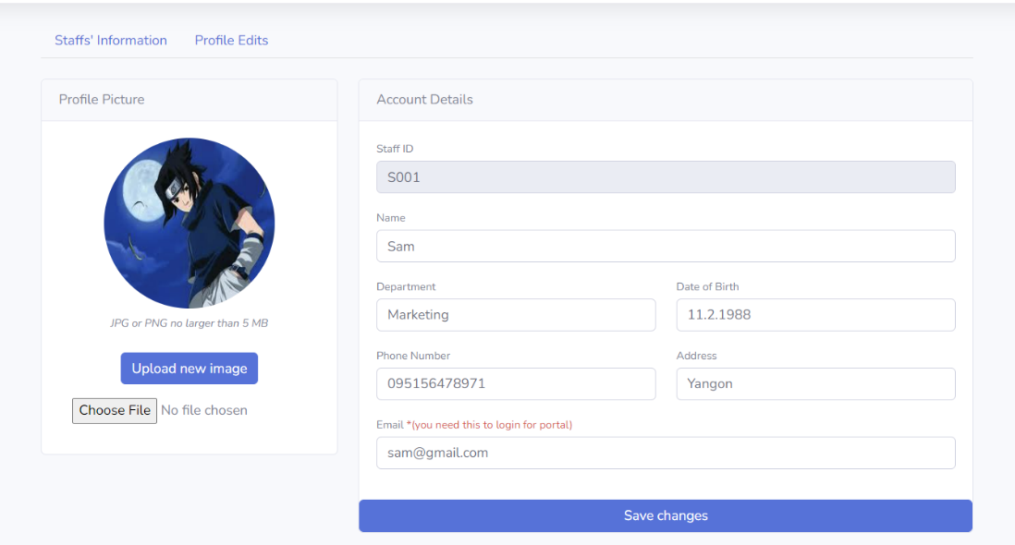

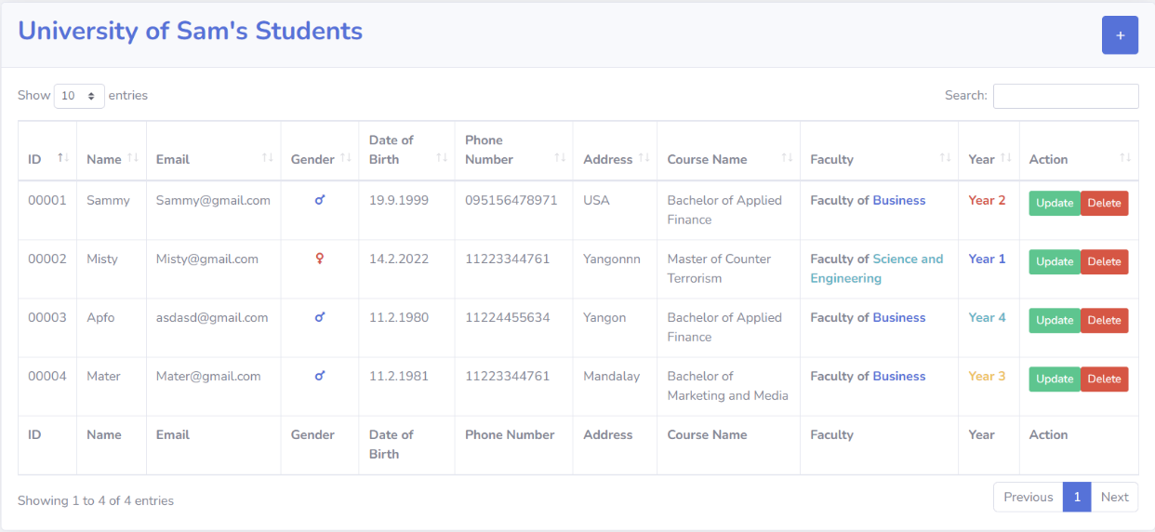

This is for student information, just like it is for staff. You can click the icon to add more students to this.

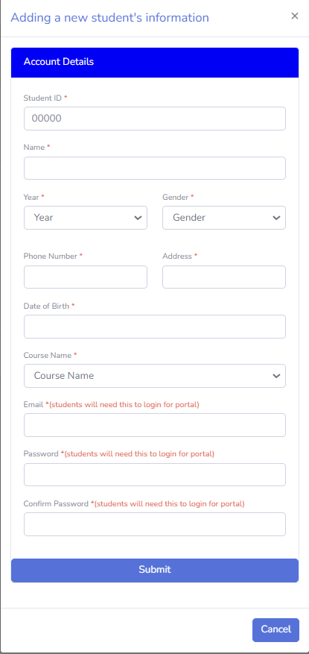

The adding form is readily added by staff members and is well-validated for both students and staff.

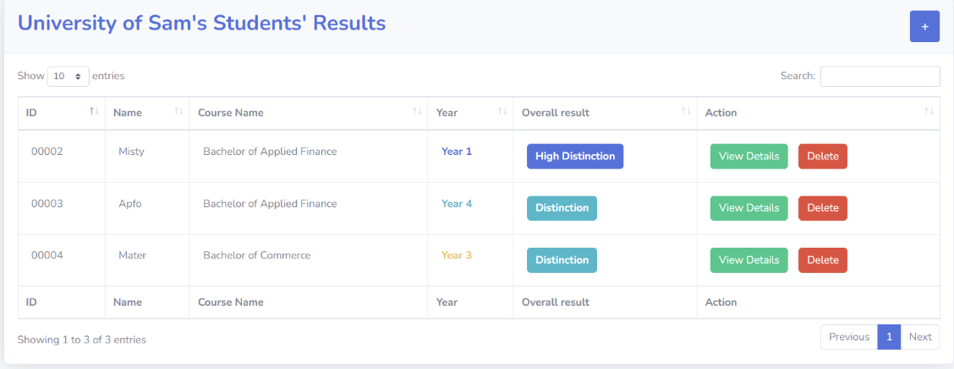

This is for the student exam result. Staff members must put the module mark after the overall result. After clicking the “View Details” button on a student's result, the following alert box will appear if there isn't a module mark.

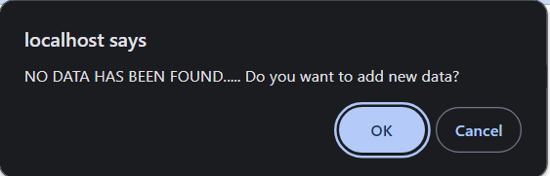

The module names are automatically derived from the database for the corresponding course.

The following adding module mark will appear if you click OK.

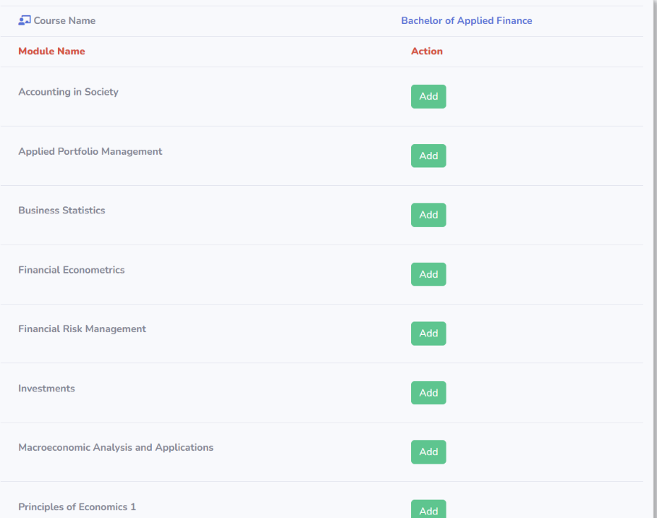

By clicking the Add button, staff members can add student marks to the corresponding course module.

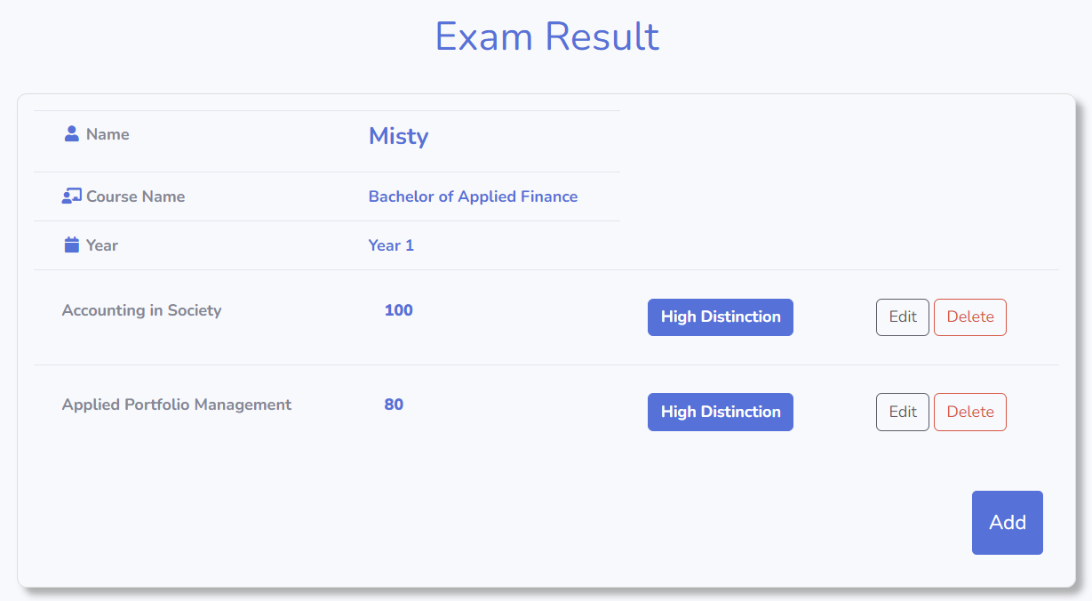

This contains a student's exam results details, which staff members are able to edit or remove. Here, I'll demonstrate how the Edit Button functions.

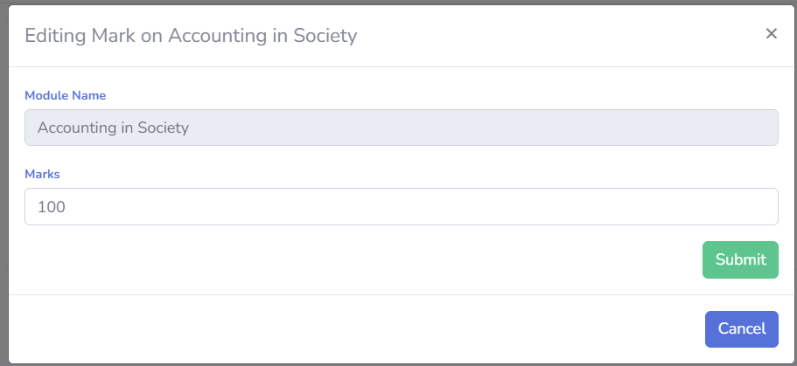

By inputting the desired update number, staff members can modify the student module marks.

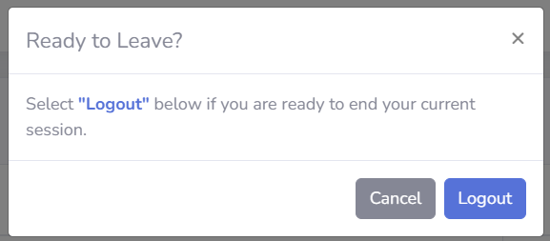

You can click the log out link in your profile to bring up the confirmation box. Clicking Logout will log you out of your account and take you to the Staff Login Page.

## **Student Portal**

You can come to the “Student Portal Login” Page by clicking this in “Current Students” navigation bar.

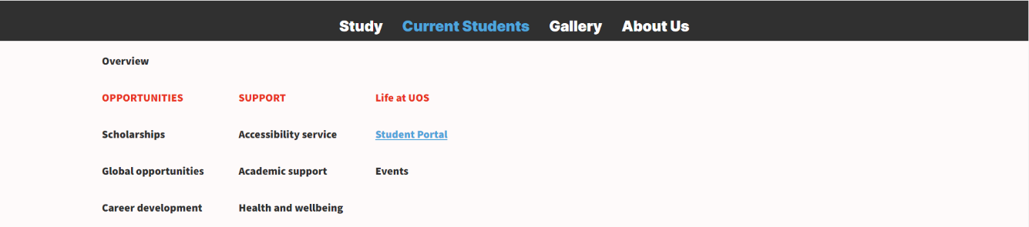

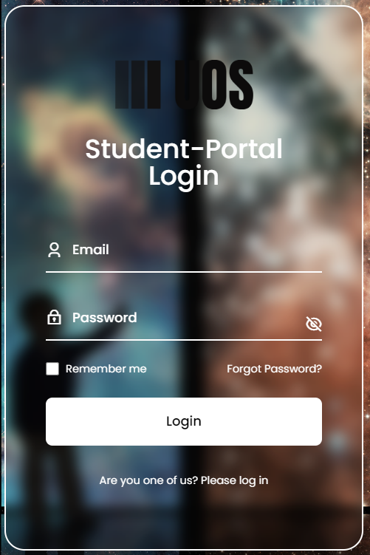

Similar to the Staff Login, students need to fill out a form with accurate information.

This is the student portal's welcome page. By using those navigation buttons, you can navigate to a different section.

Additionally, by clicking this, you can view, amend, or log out of your profile.

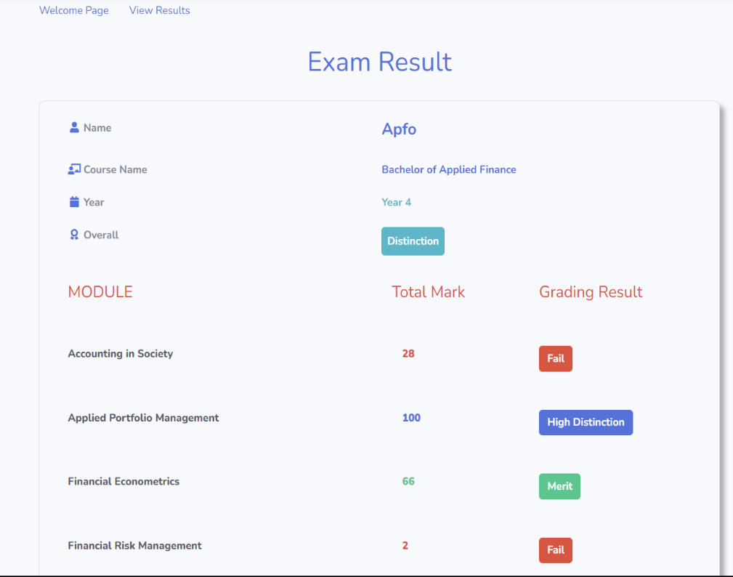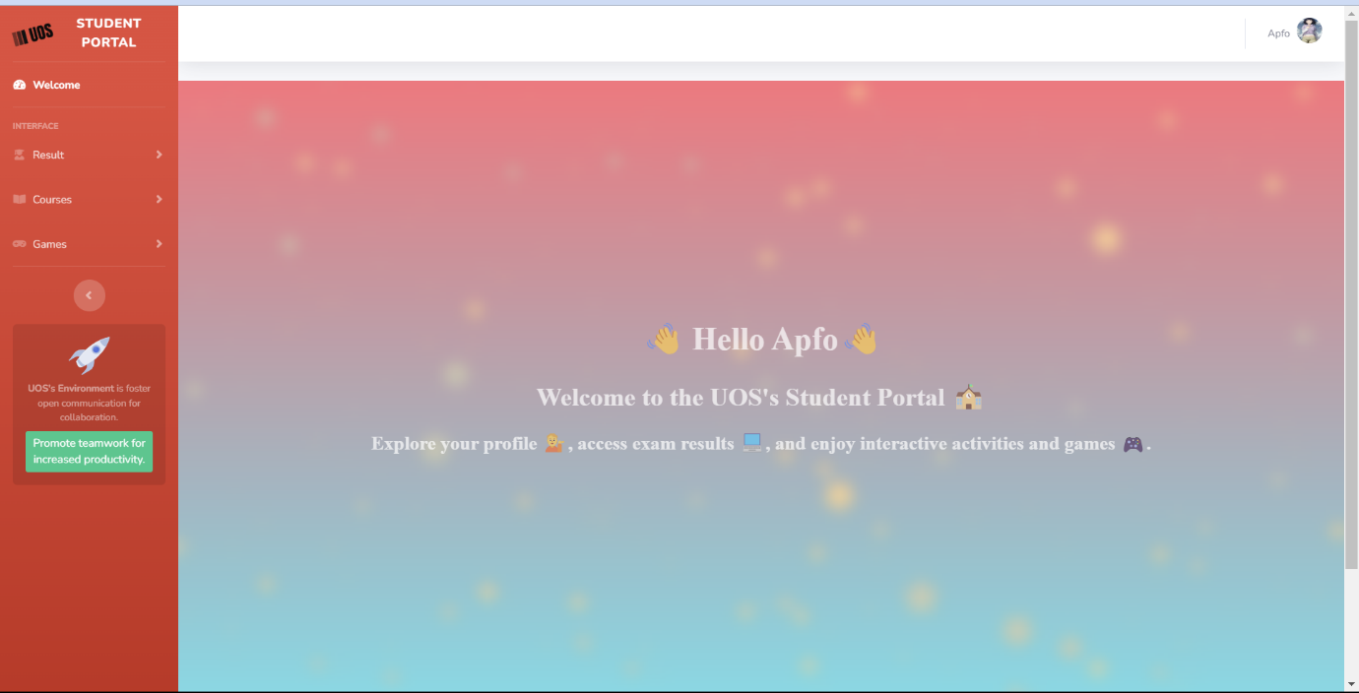

This is the outcome for each individual student.

Students can choose the entries which will be appeared in the table.

Students can click on the table headers to sort the table as well.

The courses offered at UOS can be viewed by students, who can also search for them by name.

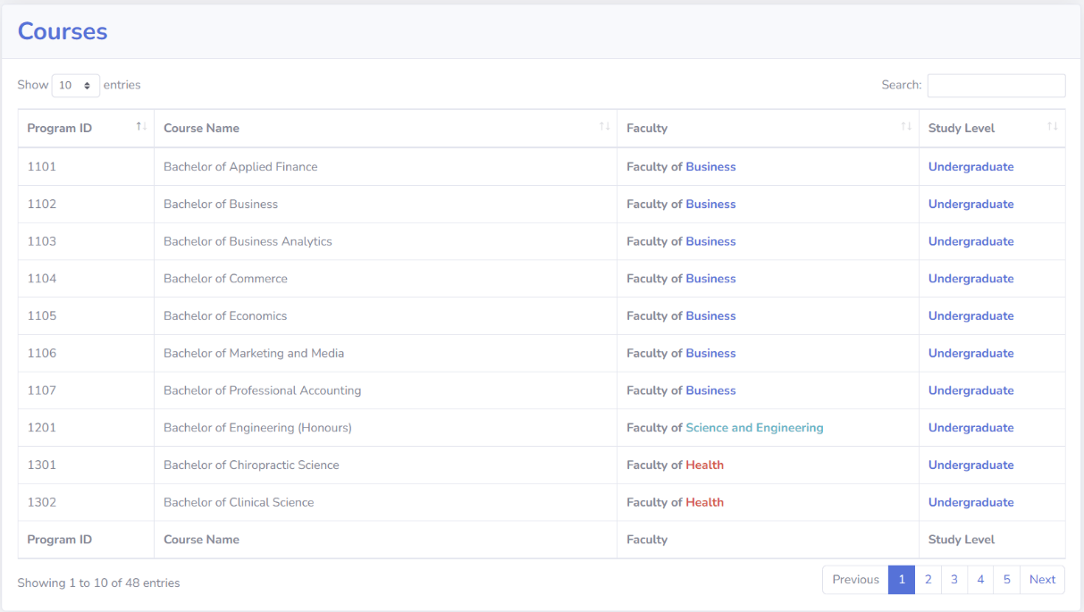

Students can also move to the next page.

It shows the total numbers of entry

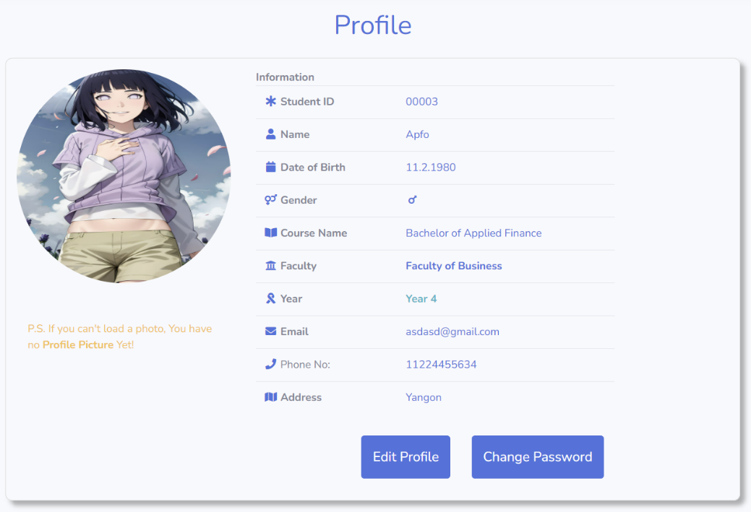

Only in the event that the new password is a strong password will the Submit button appear.

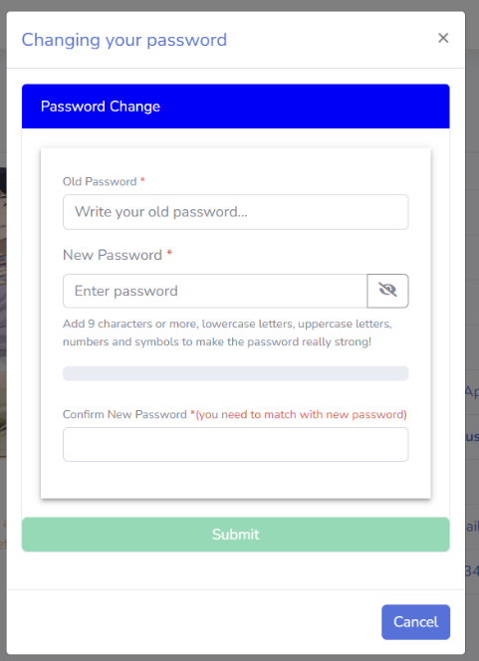

The student's own profile will show up, similar to that of the staff; click the edit option to make any modifications. To modify the password, click the Change Password button.

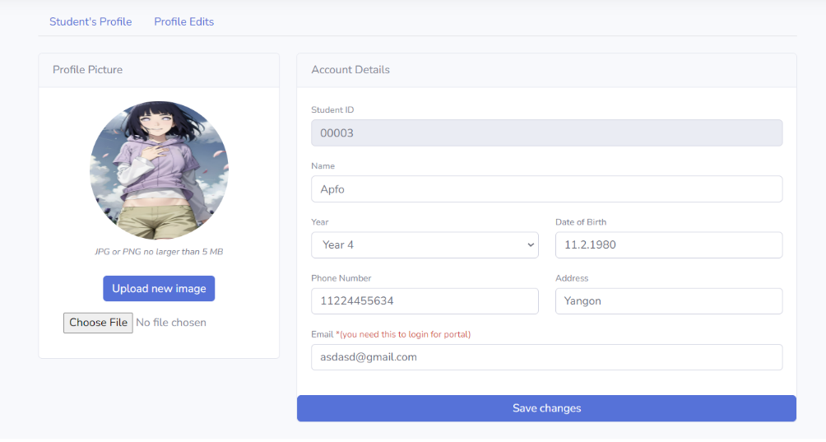

Students can submit photos and change their personal information, just like staff members can.

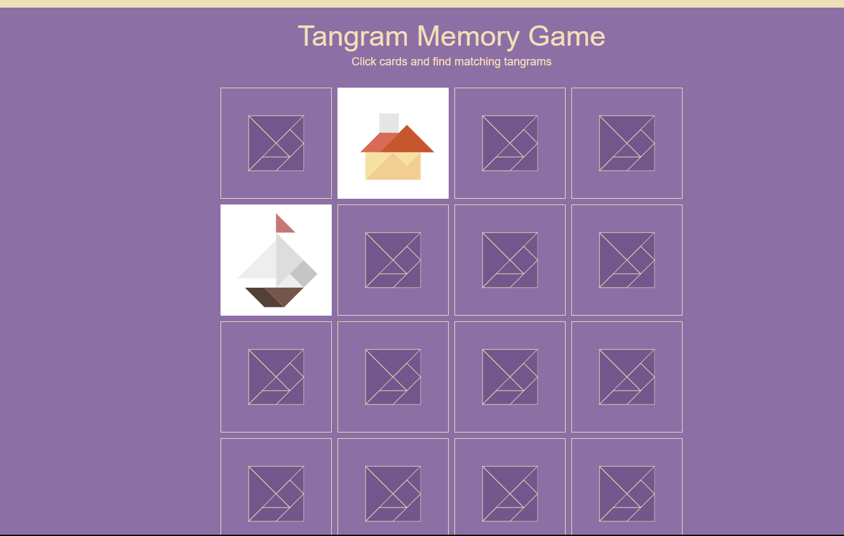

This student portal offers activities like Memory Game and Tic Tac Toe that students can enjoy.

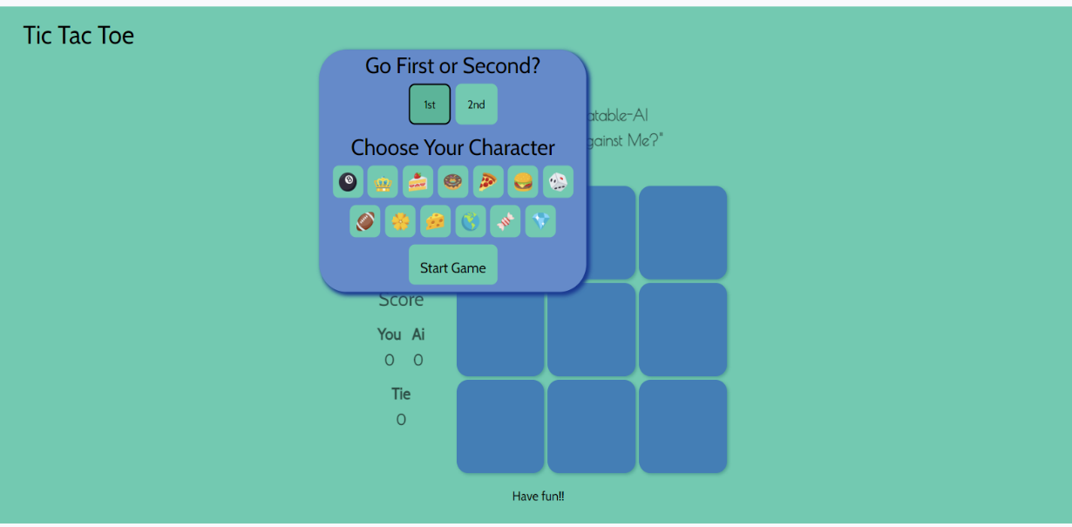

# **Troubleshooting & Support**

At the University of Sam (UOS), we recognize that consumers may occasionally run into difficulties using our online resources. Our support and troubleshooting services are available to help you get past any obstacles and guarantee a seamless, enjoyable online experience.

1. Common Issues and Solutions:

* Login Problems: Make sure CAPS LOCK is off and double-check your login information if you're having problems logging in.
* Browser Compatibility: For best results, make sure your browser is supported and up to date.
* Loading delays: Internet problems can be the cause of slow loading times. Go back and check the page or your internet connection.

1. Email Support:

* Please send our support team an email describing the problem you are having.
* For a speedier resolution, include any pertinent information, such as error messages or screenshots.

1. Phone Support:

* Contact our helpline to get help right away.
* Your problems will be addressed, and our expert support staff will walk you through the troubleshooting process.

1. Feedback Mechanism:

* Please share your thoughts about our support services.
* Your suggestions enable us to continuously raise user satisfaction levels and improve our troubleshooting procedures.

For a Smooth Resolution:

* When you ask for help, be sure to specify the problem you are having.
* Give pertinent information about the device you are using, your username, and any error messages you have seen.

At UOS, we're dedicated to providing dependable help to quickly resolve your issues. Our first goal as we collaborate is to provide a flawless online experience is your pleasure.

We are appreciative that you have selected UOS, where troubleshooting is a team effort aimed at ongoing progress!

# **References**

User Manual References [Online]

Available at: <https://www.techsmith.com/blog/user-documentation/>

[Accessed 1.2.2024]

Role-Based Access Control (RBAC) [Online]

Available at: <https://www.imperva.com/learn/data-security/role-based-access-control-rbac/>

[Accessed 4.2.2024]

Virtual Private Network (VPN) [Online]

Available at: <https://www.kaspersky.com/resource-center/definitions/what-is-a-vpn>

[Accessed 4.2.2024]

Two Steps Authentication (2SA) [Online]

Available at: <https://www.techtarget.com/searchsecurity/definition/two-factor-authentication>

[Accessed 29.10.2023]

Pictures and banners [Online]

Available at: <https://unsplash.com/>

[Accessed 31.10.2023]